Prometheus & Grafana

TASK 1: Install Prometheus on a server and configure prometheus.yml.
Step 1: Download Prometheus
Go to official site:
- https://prometheus.io/download
cd /opt
sudo wget https://github.com/prometheus/prometheus/releases/download/v2.53.4/prometheus-2.53.4.linux-amd64.tar.gz
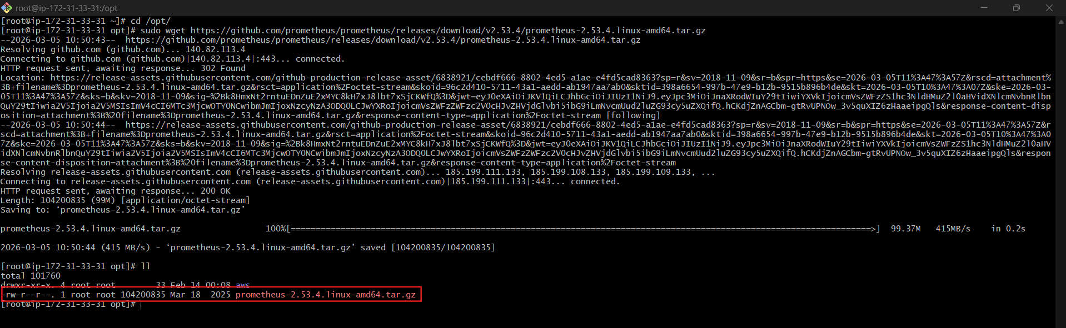
sudo tar -xvf prometheus-*.linux-amd64.tar.gz
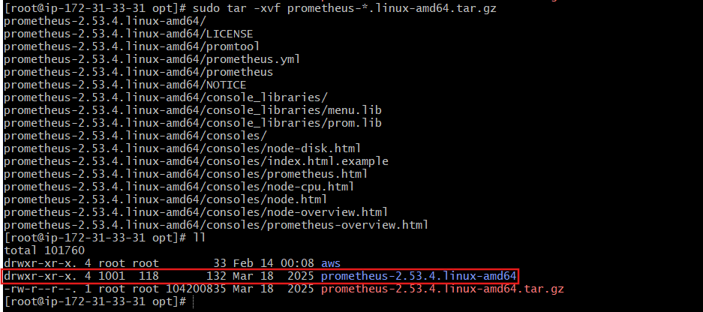
cd prometheus-*
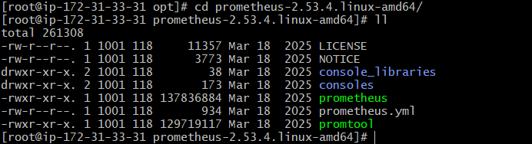

Step 2: Check Default Config
cat prometheus.yml
You will see default job monitoring itself.
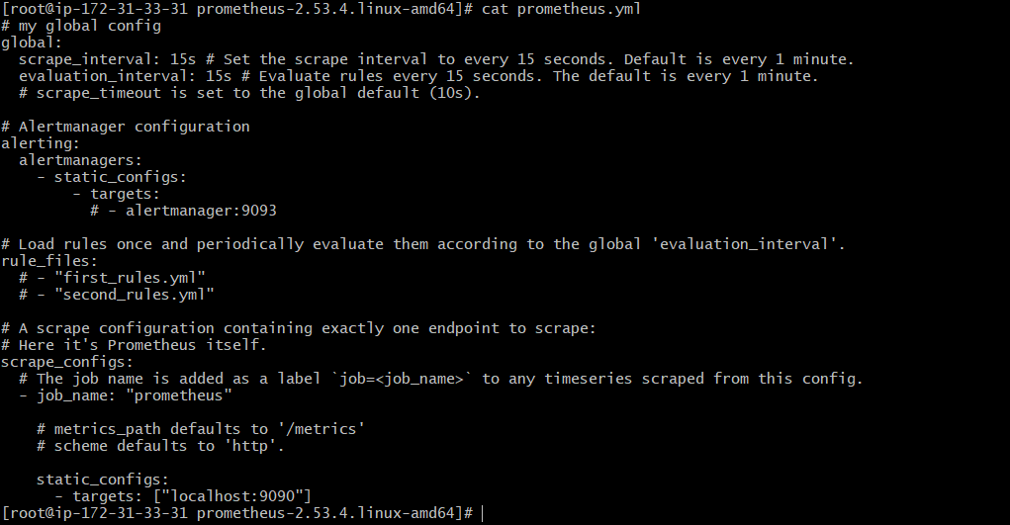
Explanation
Prometheus has 3 main components:
- Retrieval – Pull metrics from targets
- TSDB – Stores time-series data
- HTTP Server – UI runs on port 9090
Prometheus uses PromQL for querying metrics.

Step 3: Start Prometheus
./prometheus --config.file=prometheus.yml
Access:
http://PROM_SERVER_IP:9090
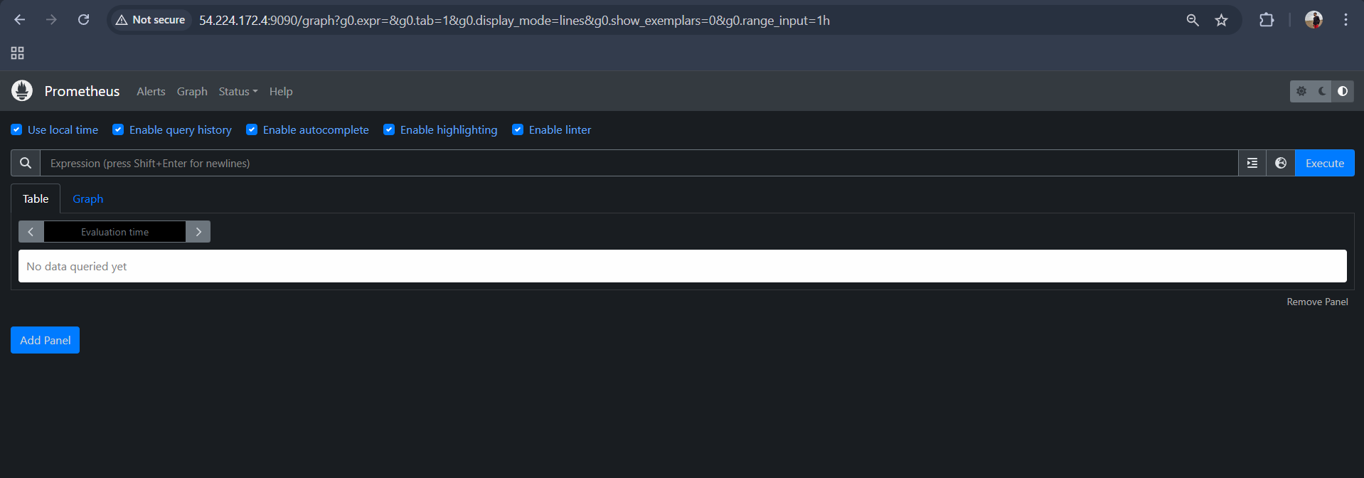
Validation
Go to:
Status → Targets
You should see:
job: prometheus
state: UP
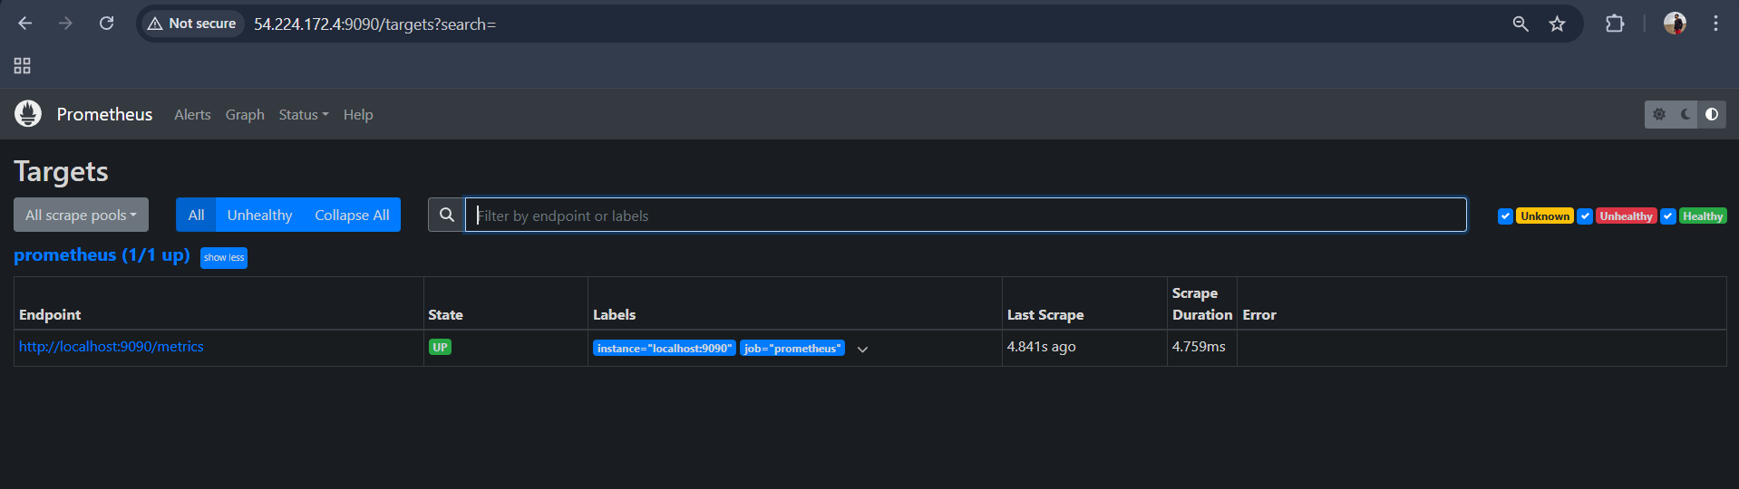

TASK 2: Install and configure Node Exporter for system monitoring.
Step 1: Download Node Exporter
cd /opt
sudo wget https://github.com/prometheus/node_exporter/releases/download/v1.10.2/node_exporter-1.10.2.linux-amd64.tar.gz
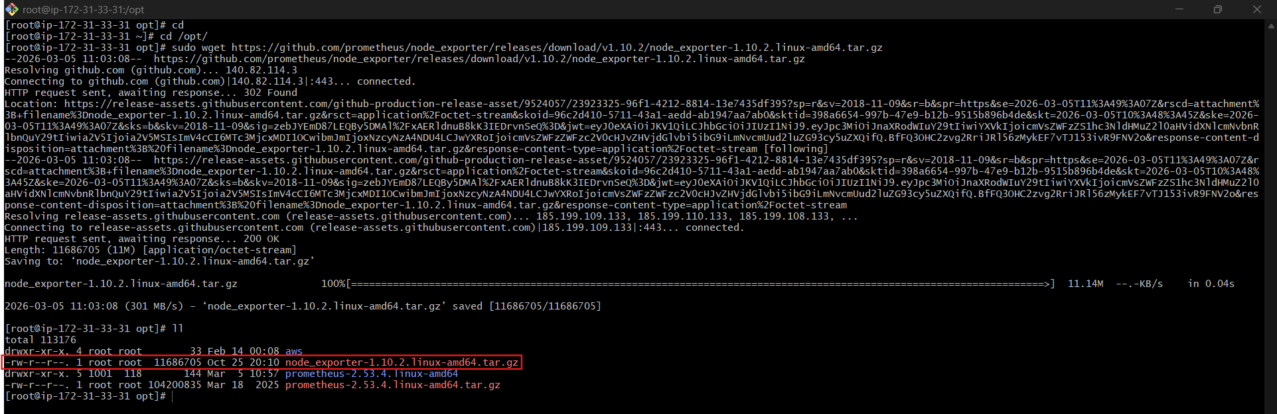
sudo tar -xvf node_exporter-1.10.2.linux-amd64.tar.gz
cd node_exporter-1.10.2.linux-amd64
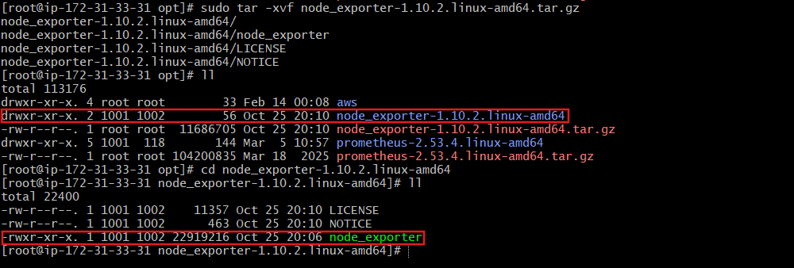
Start manually:
./node_exporter
Access:
http://SERVER_IP:9100/metrics
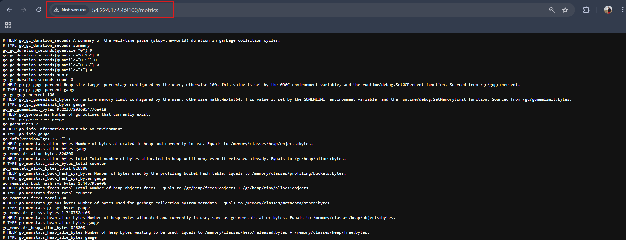
Explanation
Node Exporter collects:
- CPU
- Memory
- Disk
- Filesystem
- Network
It exposes metrics in Prometheus format.

Step 2: Add to prometheus.yml
Edit:
vi prometheus.yml
Add:
# my global config
global:
scrape_interval: 15s
evaluation_interval: 15s

# Alertmanager configuration
alerting:
alertmanagers:
- static_configs:
- targets:
# - alertmanager:9093

rule_files:
# - "first_rules.yml"
# - "second_rules.yml"

scrape_configs:
- job_name: "prometheus"
static_configs:
- targets: ["localhost:9090"]

- job_name: "node_exporter"
static_configs:
- targets: ["localhost:9100"]

Restart Prometheus.
./prometheus --config.file=prometheus.yml
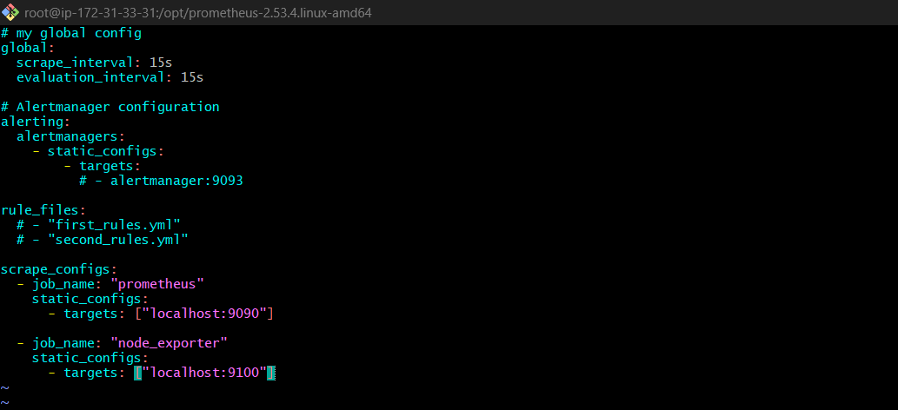

Validation
In Prometheus UI → Graph
Run:
100 - (avg by(instance)(irate(node_cpu_seconds_total{mode="idle"}[1m])) * 100)
You should see CPU usage graph.

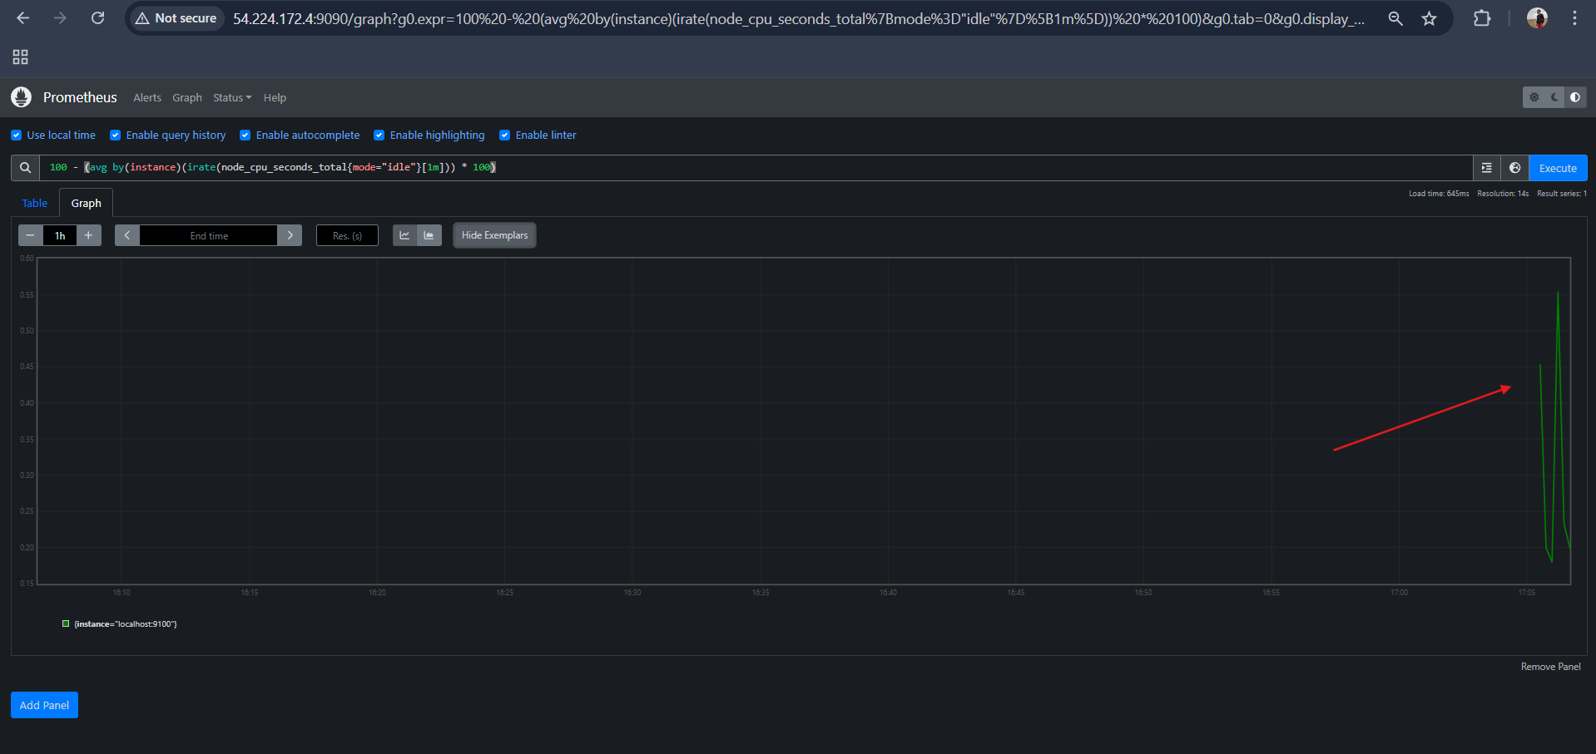

TASK 3: Set up SNMP Exporter to monitor network devices.
Step 1: Download SNMP Exporter
cd /opt
wget https://github.com/prometheus/snmp_exporter/releases/download/v0.26.0/snmp_exporter-0.26.0.linux-amd64.tar.gz
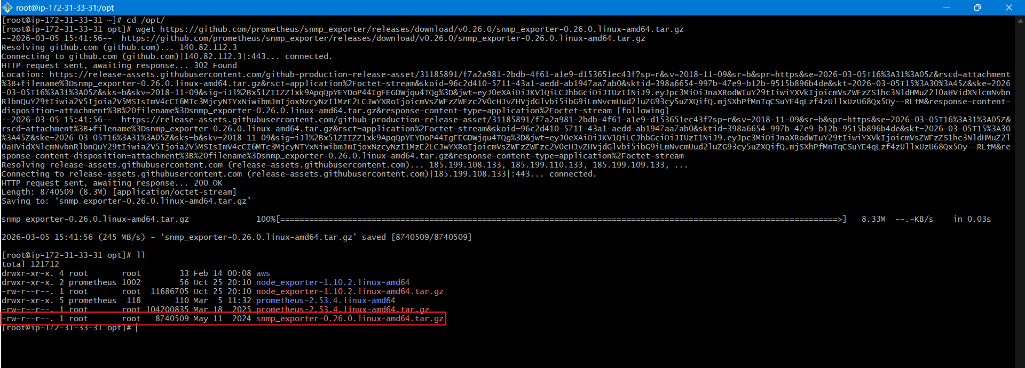
tar -xvf snmp_exporter-0.26.0.linux-amd64.tar.gz
cd snmp_exporter-0.26.0.linux-amd64
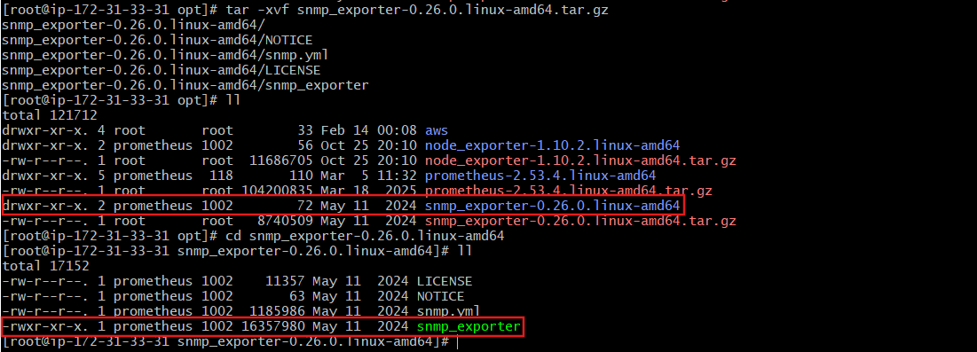
Start:
./snmp_exporter
Runs on:
http://SERVER_IP:9116
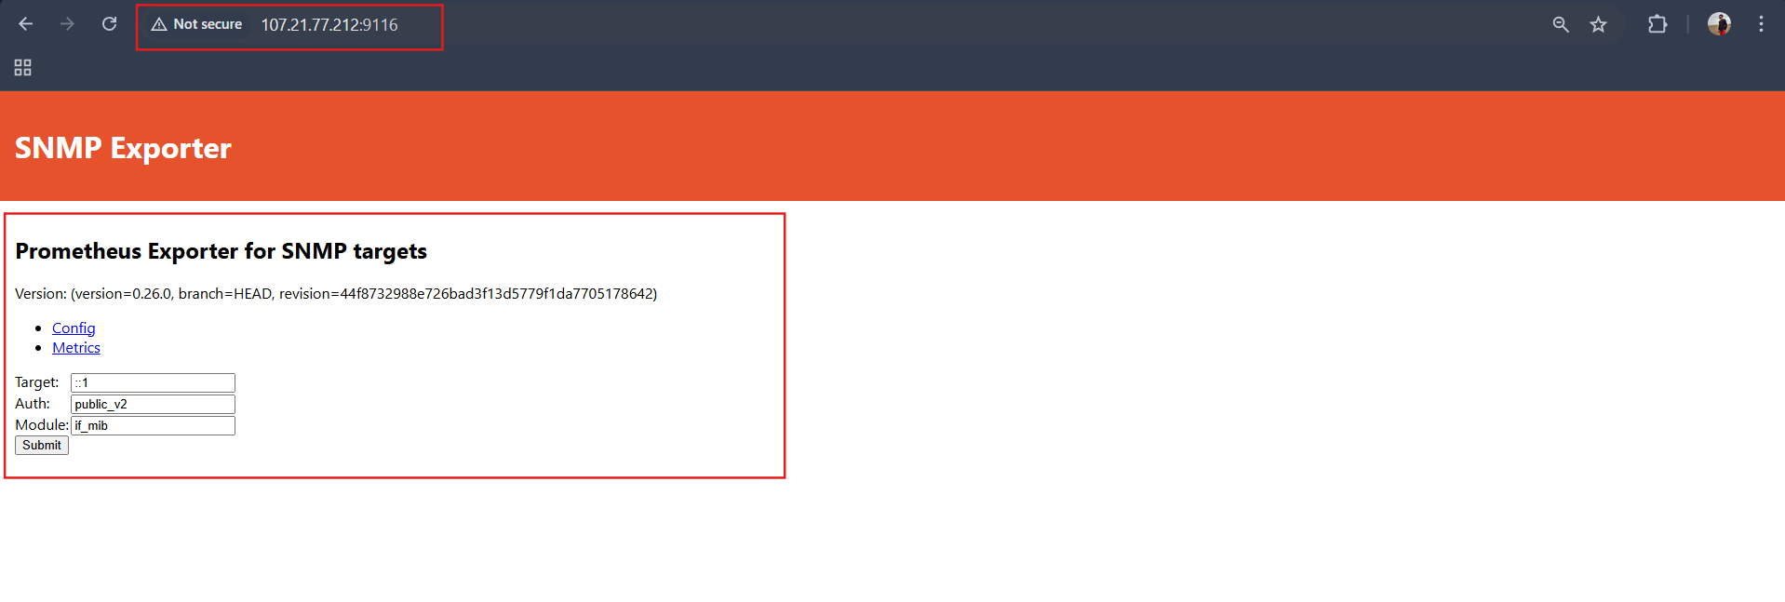

Step 2: Configure prometheus.yml
sudo vi /etc/prometheus/prometheus.yml
Add:
global:
scrape_interval: 15s

scrape_configs:

- job_name: "prometheus"
static_configs:
- targets: ["localhost:9090"]

- job_name: "node_exporter"
static_configs:
- targets: ["localhost:9100"]

- job_name: "snmp"
metrics_path: /snmp
params:
module: [if_mib]

static_configs:
- targets:
- 127.0.0.1

relabel_configs:
- source_labels: [__address__]
target_label: __param_target

- source_labels: [__param_target]
target_label: instance

- target_label: __address__
replacement: localhost:9116
Restart Prometheus.
sudo systemctl daemon-reload
sudo systemctl restart prometheus
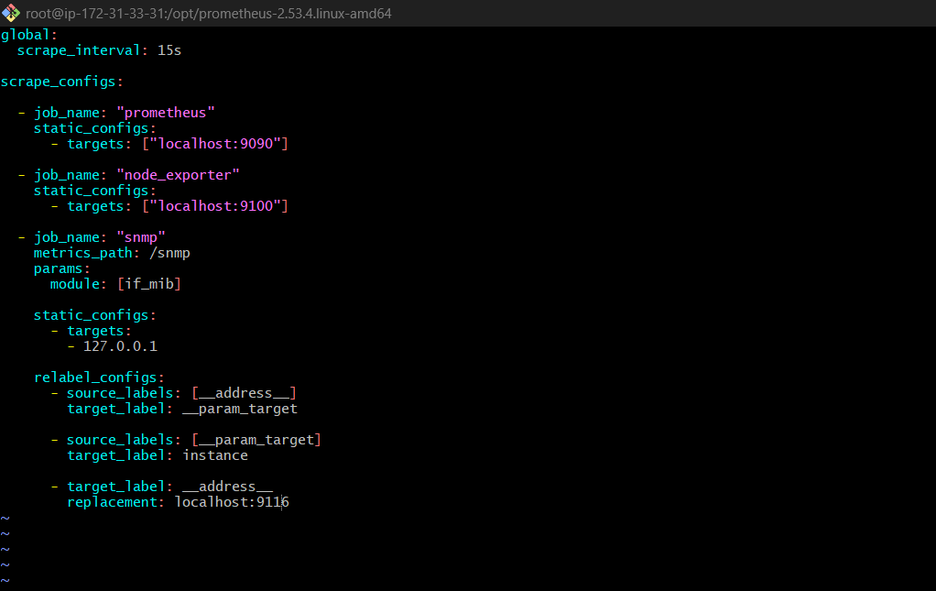
Explanation
SNMP Exporter:
- Collects metrics from routers/switches
- Uses SNMP protocol
- Converts SNMP data to Prometheus format

Validation
Prometheus → Status → Targets
snmp → UP
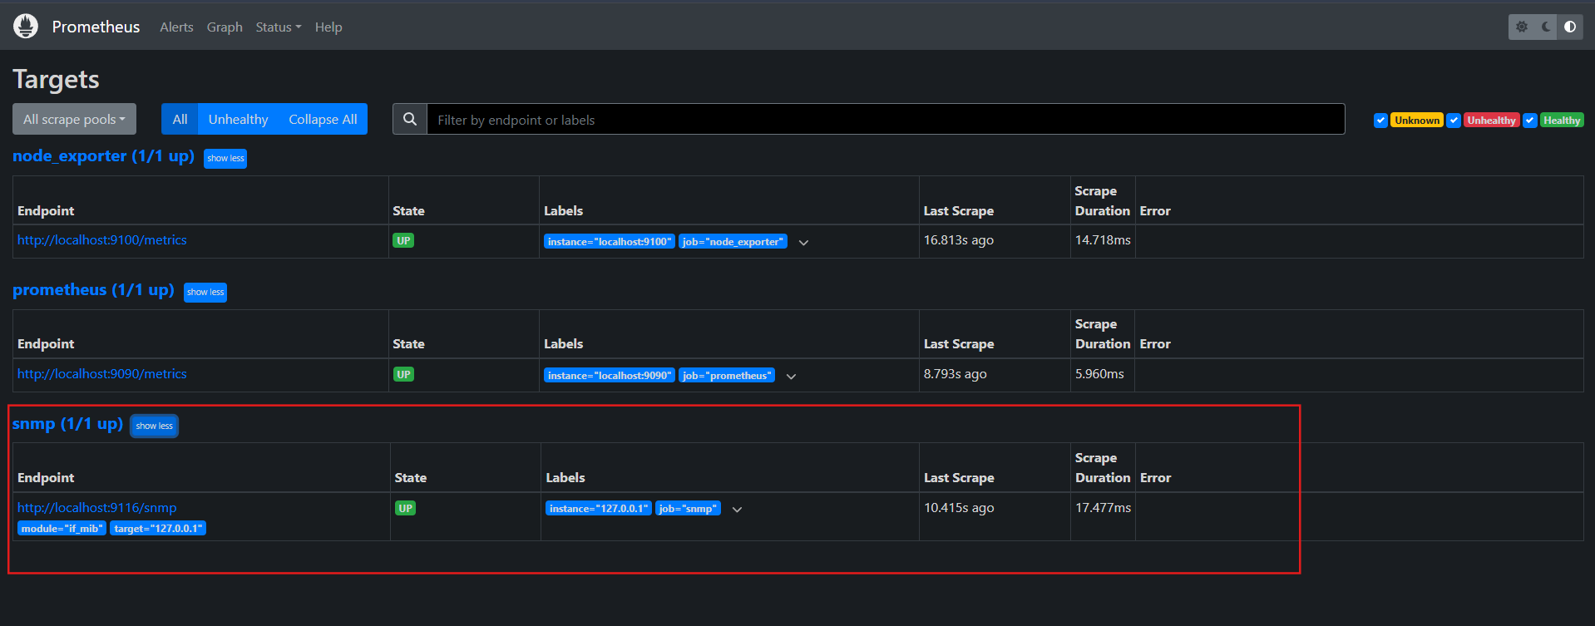

TASK 4: Set up Prometheus to run as a systemd service for automatic startup.
1️⃣ Create the Prometheus Service File
Run:
sudo vi /etc/systemd/system/prometheus.service
Paste:
[Unit]
Description=Prometheus Monitoring
Wants=network-online.target
After=network-online.target

[Service]
User=prometheus
ExecStart=/usr/local/bin/prometheus \
--config.file=/etc/prometheus/prometheus.yml \
--storage.tsdb.path=/var/lib/prometheus

Restart=always

[Install]
WantedBy=multi-user.target

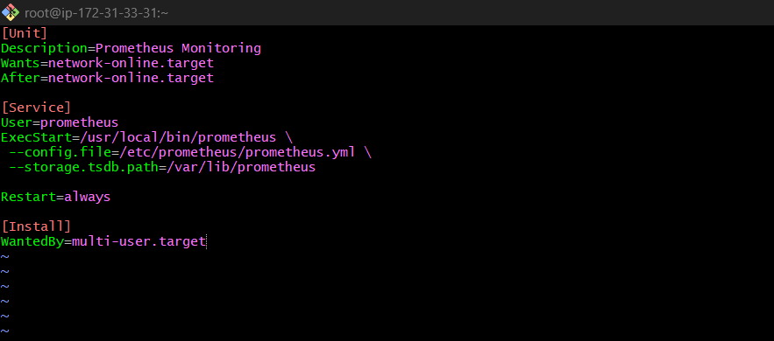
Explanation
- Description → Name of the service
- After=network.target → Start Prometheus after network is ready
- ExecStart → Command to start Prometheus
- Restart=always → Restart automatically if it crashes
- WantedBy=multi-user.target → Start automatically when server boots

2️⃣ Reload systemd
Whenever you create a new service file, reload systemd.
sudo systemctl daemon-reload

3️⃣ Start Prometheus Service
sudo systemctl start prometheus

4️⃣ Enable Auto Start at Boot
sudo systemctl enable prometheus
This ensures Prometheus starts automatically after reboot.
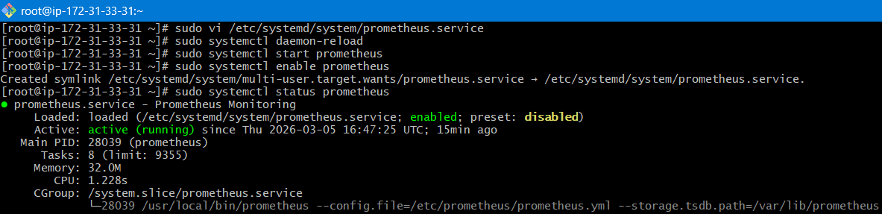
Validation Steps
Check Service Status
sudo systemctl status prometheus
You should see something like:
Active: active (running)
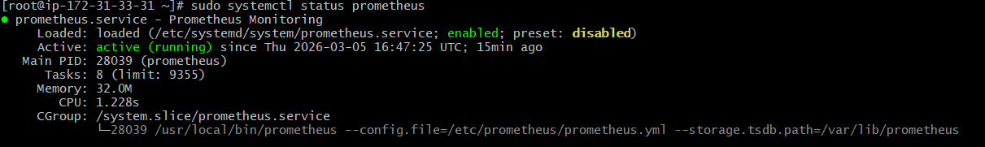
Check Prometheus Port
ss -tulpn | grep 9090
Expected:
LISTEN 0 128 *:9090
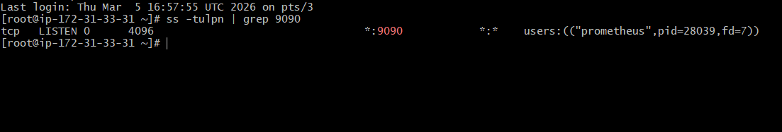
Check Prometheus UI
Open browser:
http://<server-ip>:9090
Example:
http://172.31.33.31:9090
You should see the Prometheus dashboard.
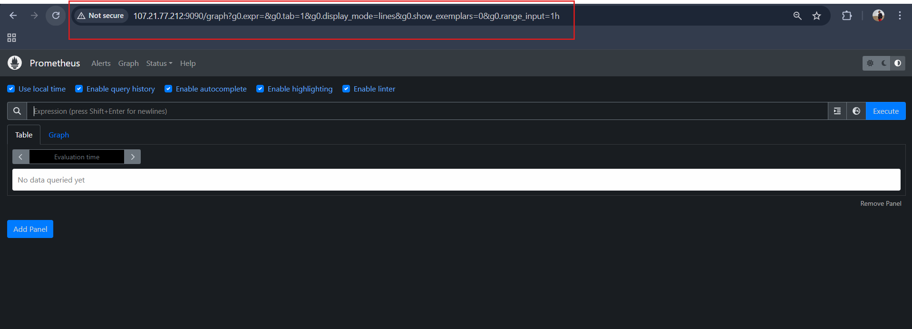
Check Targets
Go to:
Status → Targets
You should see:
- prometheus
- node_exporter
- snmp (if configured)
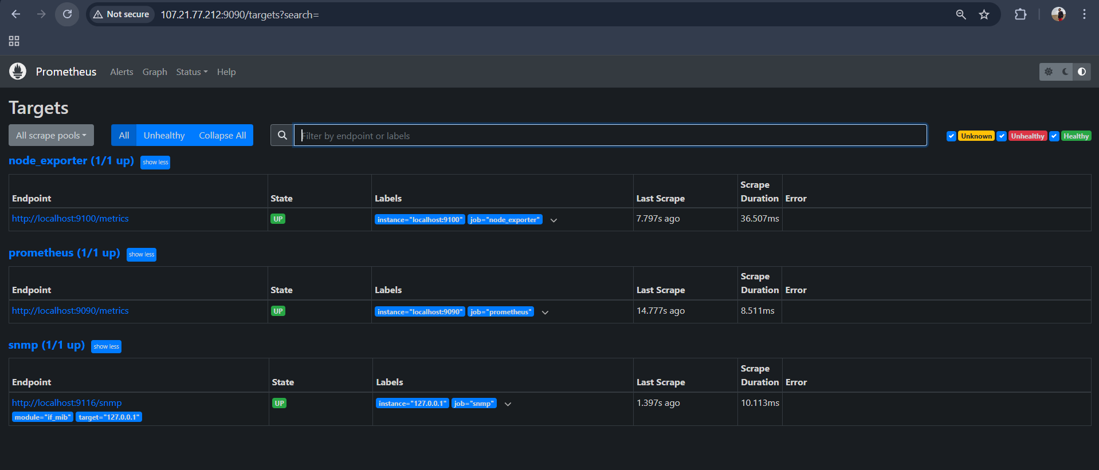

TASK 5: Install Alertmanager and configure an email alert.
Step 1: Install Alertmanager
cd /opt
wget https://github.com/prometheus/alertmanager/releases/download/v0.31.1/alertmanager-0.31.1.linux-amd64.tar.gz
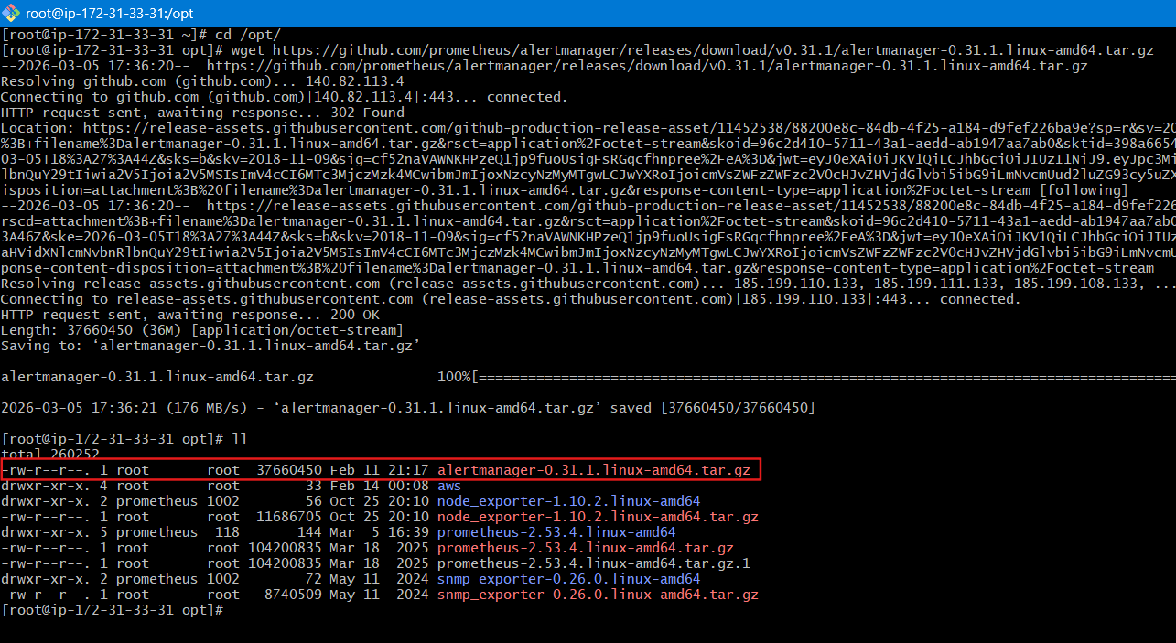
tar -xvf alertmanager-0.31.1.linux-amd64.tar.gz
cd alertmanager-0.31.1.linux-amd64
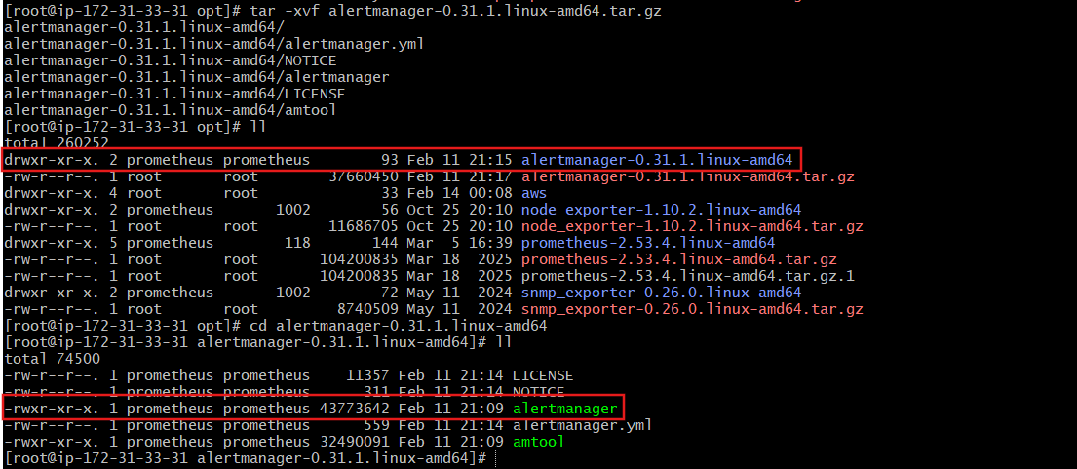
Start Alertmanager:
./alertmanager
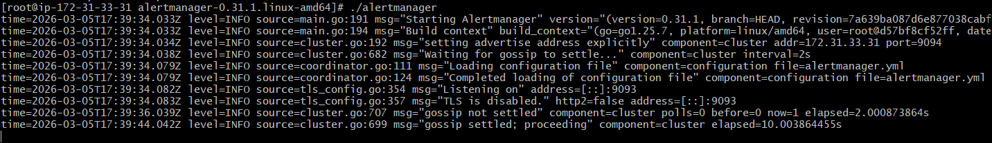
Runs on:
http://<server-ip>:9093
Explanation
Alertmanager receives alerts from Prometheus and sends notifications (email, Slack, etc.).
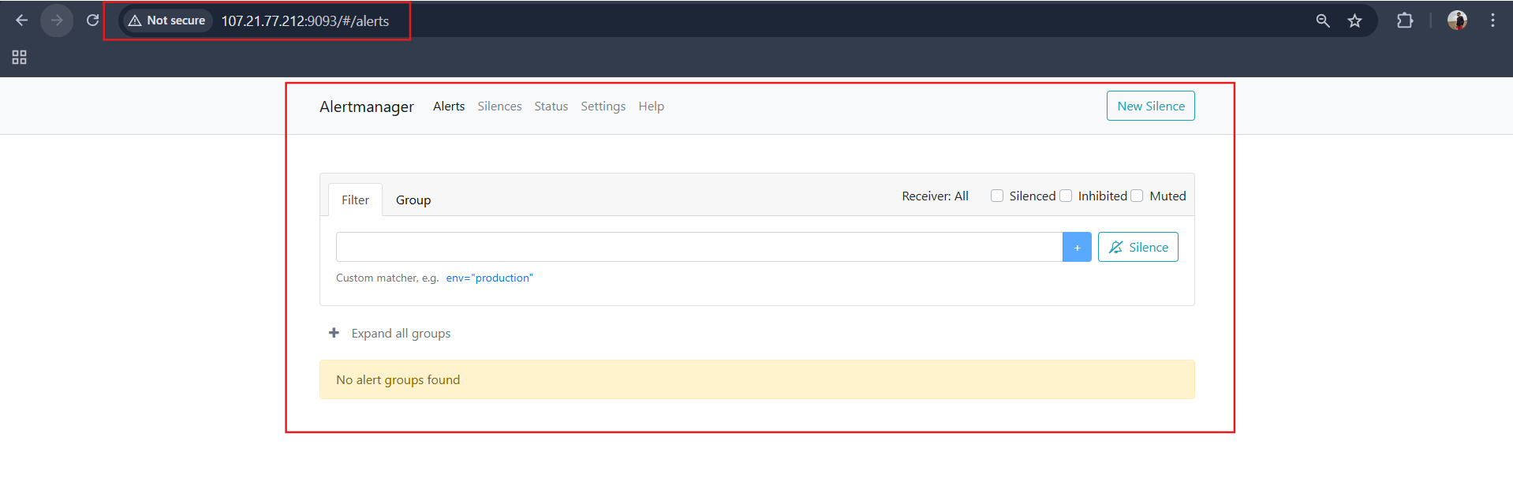
Step 2: Configure Alertmanager (Webhook instead of Email)
Edit config:
vi alertmanager.yml
Replace with:
route:
receiver: "webhook"
receivers:
- name: "webhook"
webhook_configs:
- url: "http://127.0.0.1:5001/"
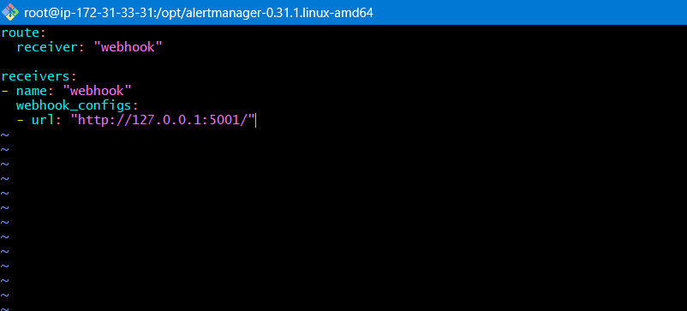
Explanation
Instead of sending email, alerts will be sent to a local webhook endpoint.

Step 3: Connect Alertmanager to Prometheus
Edit Prometheus config:
sudo vi /etc/prometheus/prometheus.yml
Add:
global:
scrape_interval: 15s

alerting:
alertmanagers:
- static_configs:
- targets:
- "localhost:9093"

scrape_configs:

- job_name: "prometheus"
static_configs:
- targets: ["localhost:9090"]

- job_name: "node_exporter"
static_configs:
- targets: ["localhost:9100"]

- job_name: "snmp"
metrics_path: /snmp
params:
module: [if_mib]

static_configs:
- targets:
- 127.0.0.1

relabel_configs:
- source_labels: [__address__]
target_label: __param_target

- source_labels: [__param_target]
target_label: instance

- target_label: __address__
replacement: localhost:9116
Restart Prometheus
sudo systemctl restart prometheus
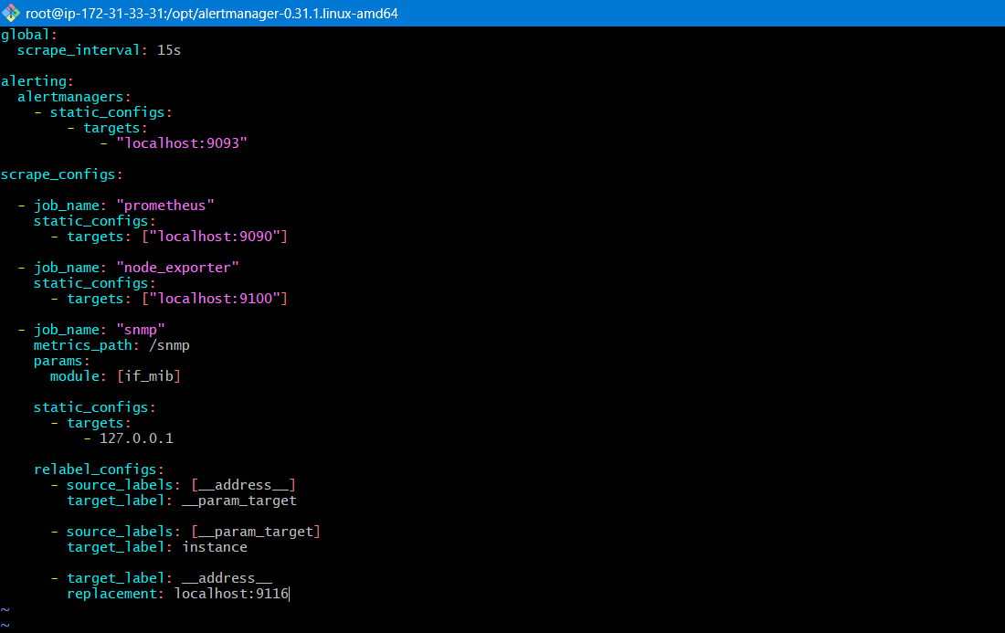
Step 4: Create a Test Alert Rule
Create alert rule file:
sudo vi /etc/prometheus/alert.rules.yml
Add:
groups:
- name: node_alerts
rules:
- alert: NodeExporterDown
expr: up{job="node_exporter"} == 0
for: 1m
labels:
severity: critical
annotations:
summary: "Node Exporter is Down"
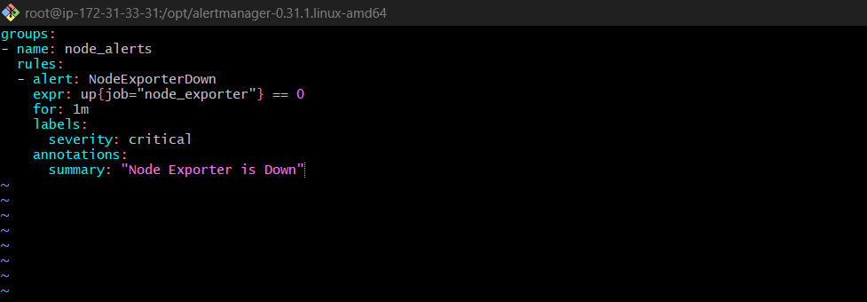
Now add this in prometheus.yml
rule_files:
- "alert.rules.yml"
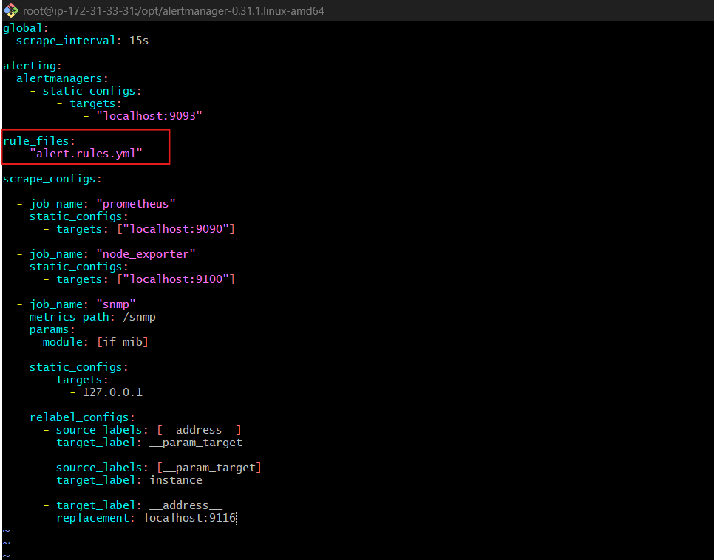
Restart Prometheus
sudo systemctl restart prometheus

Validation
Open:
http://SERVER-IP:9093
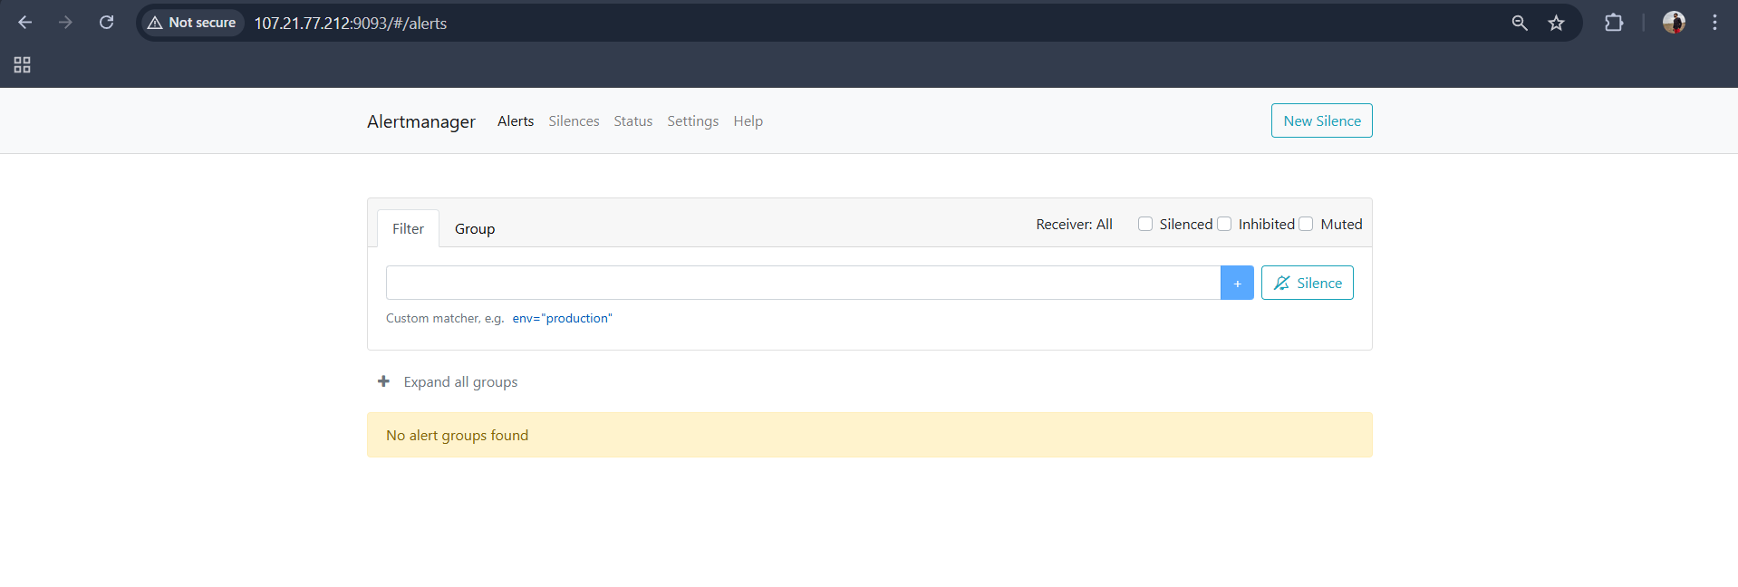
Stop node exporter
sudo systemctl stop node_exporter
Result
- Prometheus detects node_exporter DOWN
- Alert sent to Alertmanager
- Alert visible in Alertmanager UI
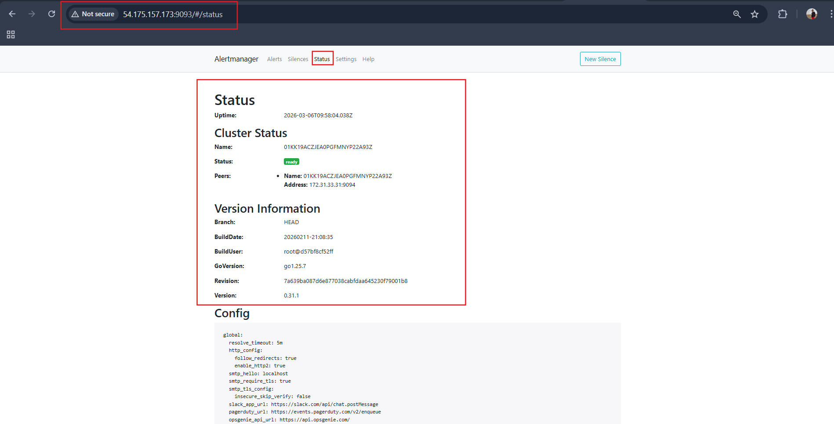

TASK 6: Install Grafana and add Prometheus as a data source.
1️⃣ Download Grafana
Download the latest Grafana package from:
- https://grafana.com/grafana/download
For Linux server (recommended method):
cd /opt
wget https://dl.grafana.com/oss/release/grafana-11.1.0.linux-amd64.tar.gz
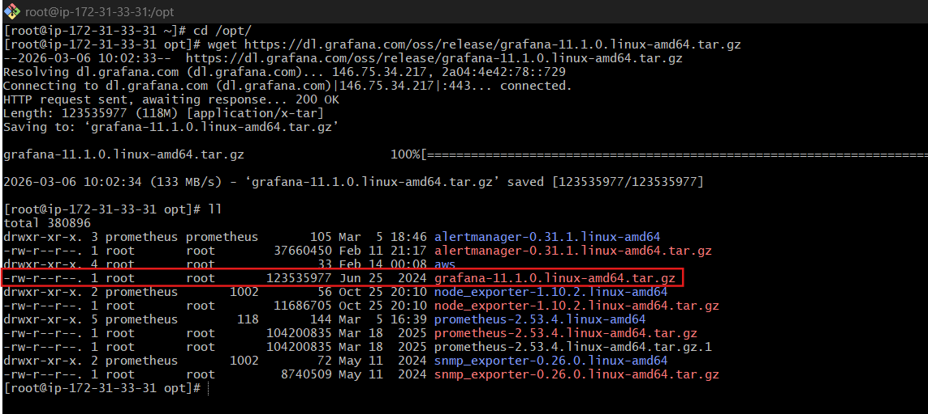
Extract it:
tar -xvf grafana-11.1.0.linux-amd64.tar.gz
Go to the Grafana directory:
cd grafana-11.1.0
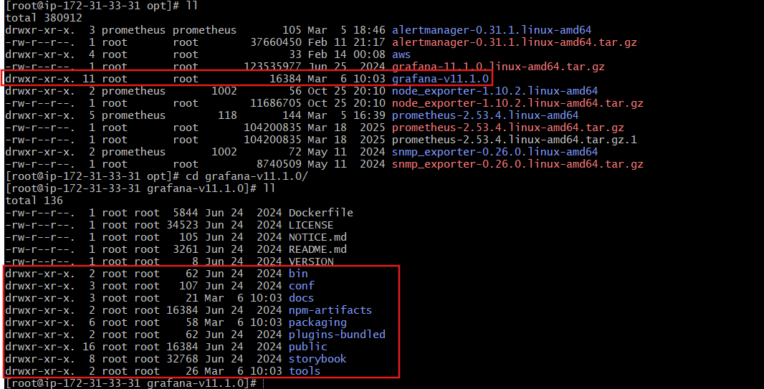
2️⃣ Start Grafana Server
Run:
./bin/grafana-server
Grafana will start and listen on:
port 3000

3️⃣ Access Grafana UI
Open browser:
http://SERVER_IP:3000
Example:
http://<EC2_PUBLIC_IP>:3000
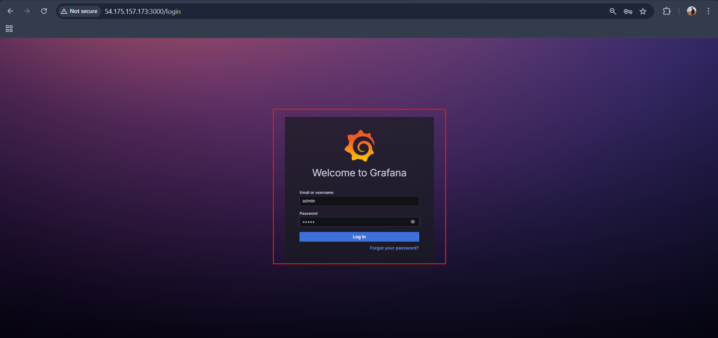
4️⃣ Login to Grafana
Default credentials:
Username: admin
Password: admin
Grafana will ask you to change the password after first login.
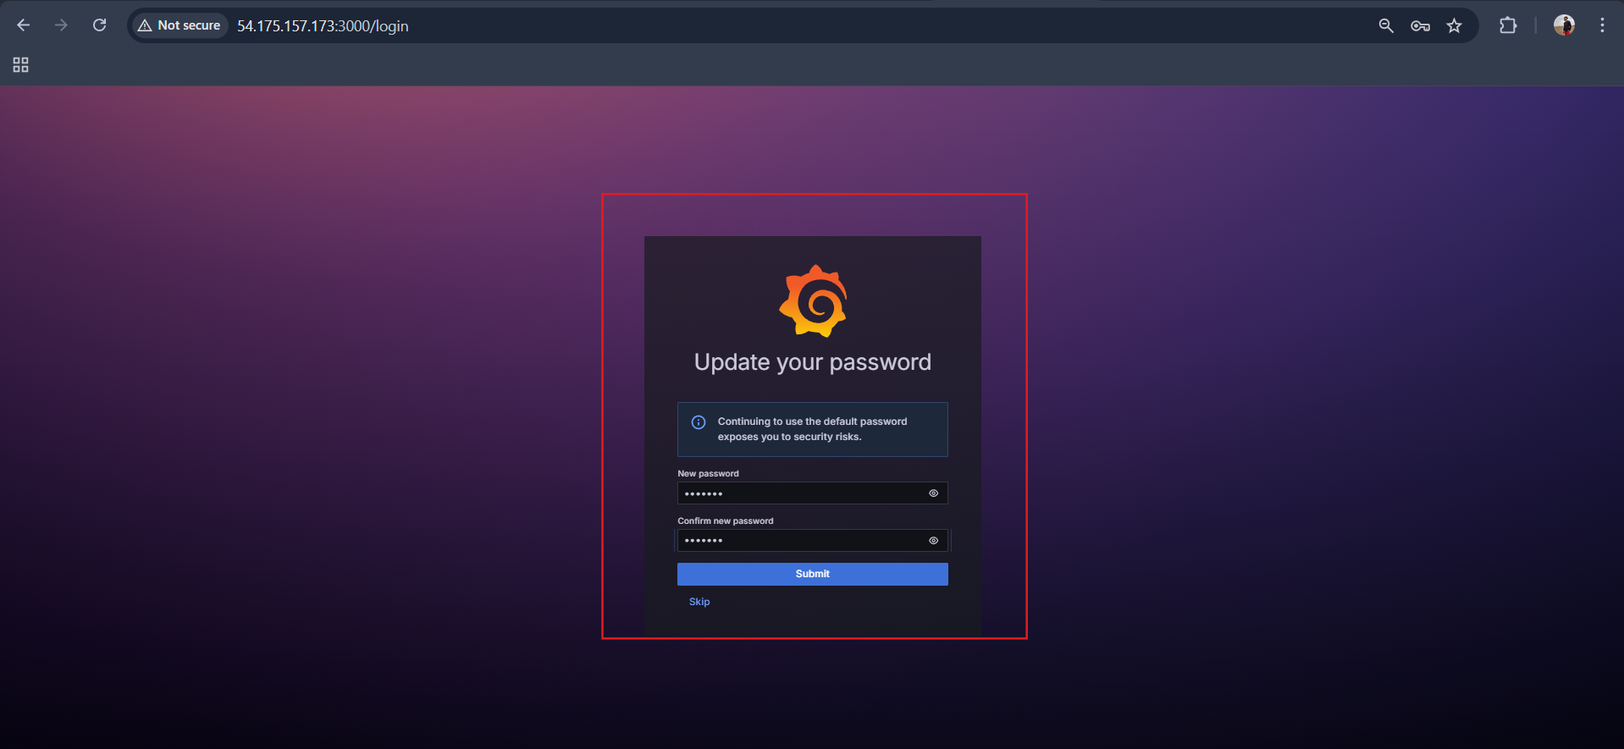
5️⃣ Add Prometheus Data Source
Inside Grafana UI:
- Click Connections
- Click Data Sources
- Click Add Data Source
- Select Prometheus
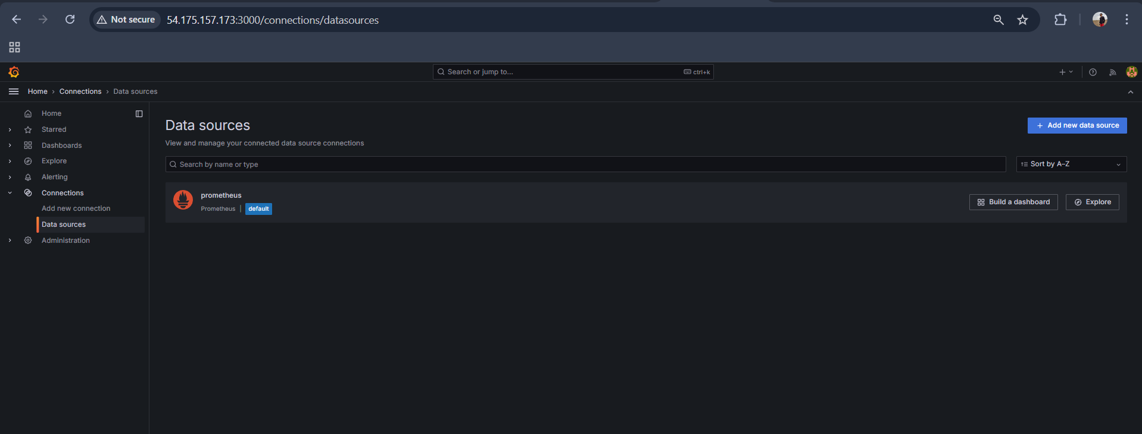
6️⃣ Configure Prometheus URL
Enter the URL:
http://localhost:9090
Click:
Save & Test
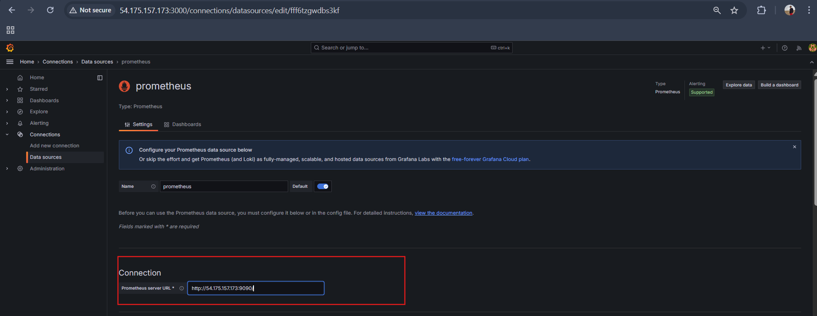
7️⃣ Validation
If everything is configured correctly, Grafana will display:
Data source is working
This confirms Grafana successfully connected to Prometheus.
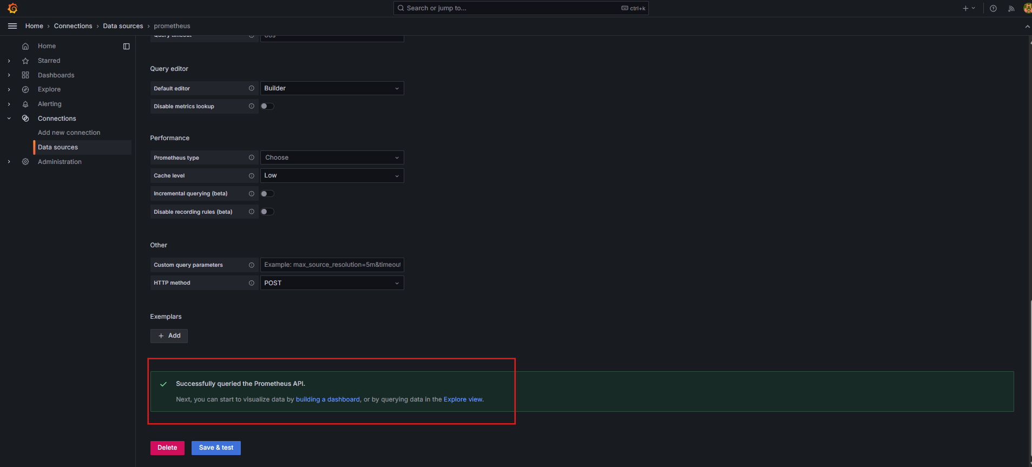

TASK 7: Configure Prometheus for service discovery of dynamic targets.
1️⃣ Attach IAM Role to Prometheus Server
Attach an IAM role to the EC2 instance running Prometheus with this policy:
{
"Version": "2012-10-17",
"Statement": [
{
"Effect": "Allow",
"Action": [
"ec2:DescribeInstances",
"ec2:DescribeTags"
],
"Resource": "*"
}
]
}
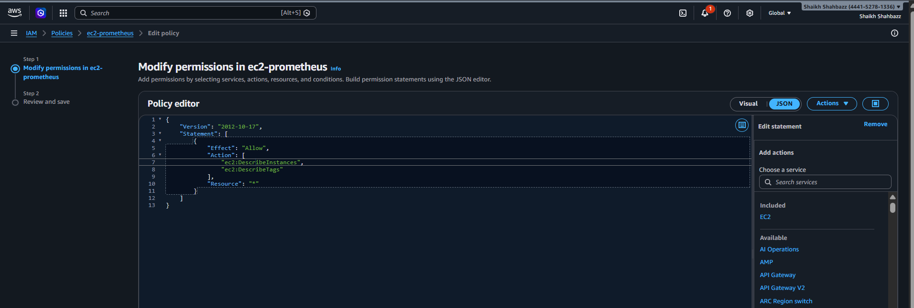

Create role and attach this policy
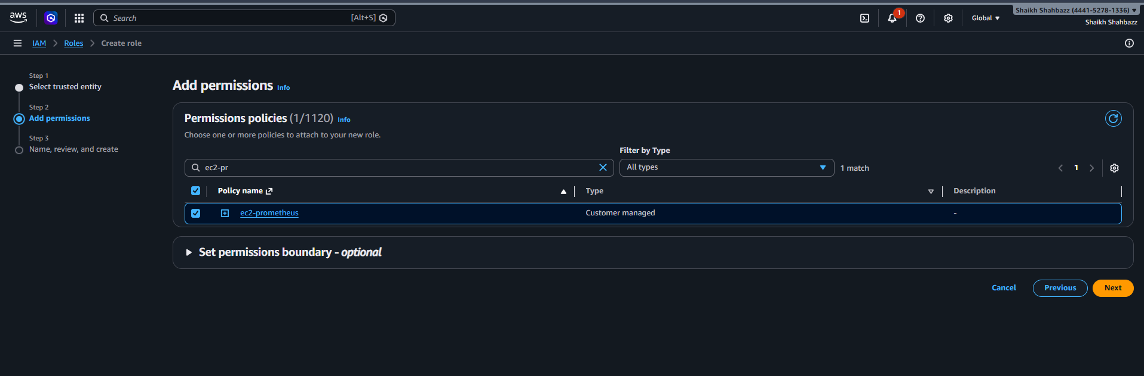
This allows Prometheus to query AWS EC2 APIs and discover instances dynamically.
Now attach this role to Prometheus ec2 server
Select instance security modify iam role
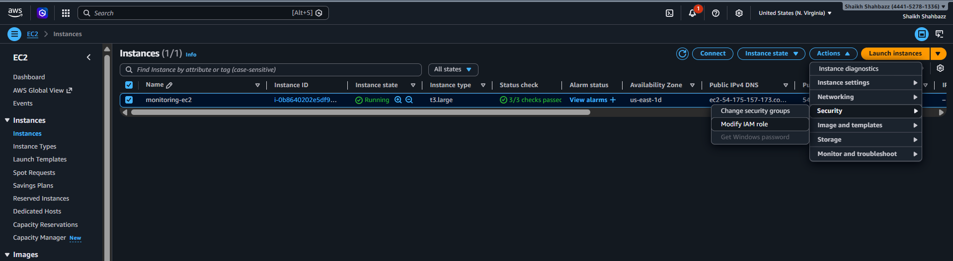

Click Update role
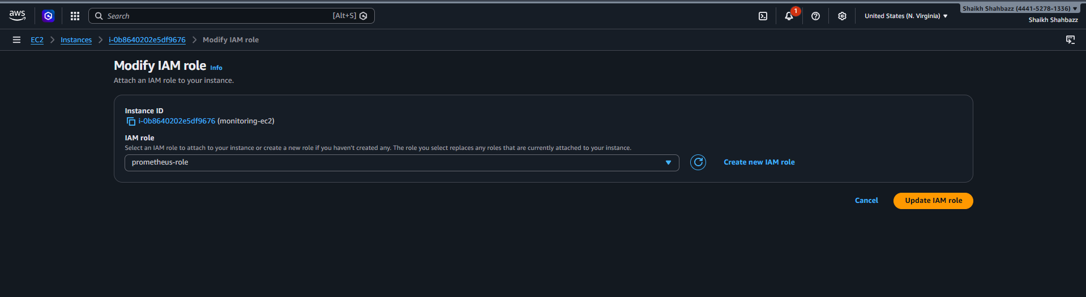

2️⃣ Update prometheus.yml
Edit the Prometheus configuration:
sudo vi /opt/prometheus-2.53.4.linux-amd64/prometheus.yml
Add this under scrape_configs:
- job_name: 'ec2-node-exporter'
ec2_sd_configs:
- region: ap-south-1
port: 9100
relabel_configs:
- source_labels: [__meta_ec2_tag_Name]
regex: prometheus-node.*
action: keep
- source_labels: [__meta_ec2_private_ip]
target_label: instance
Why this change?
- regex: prometheus-node.* → keeps only EC2 instances with tag Name starting with prometheus-node
- __meta_ec2_private_ip → ensures Prometheus scrapes the private IP, which is recommended when instances are in the same VPC.
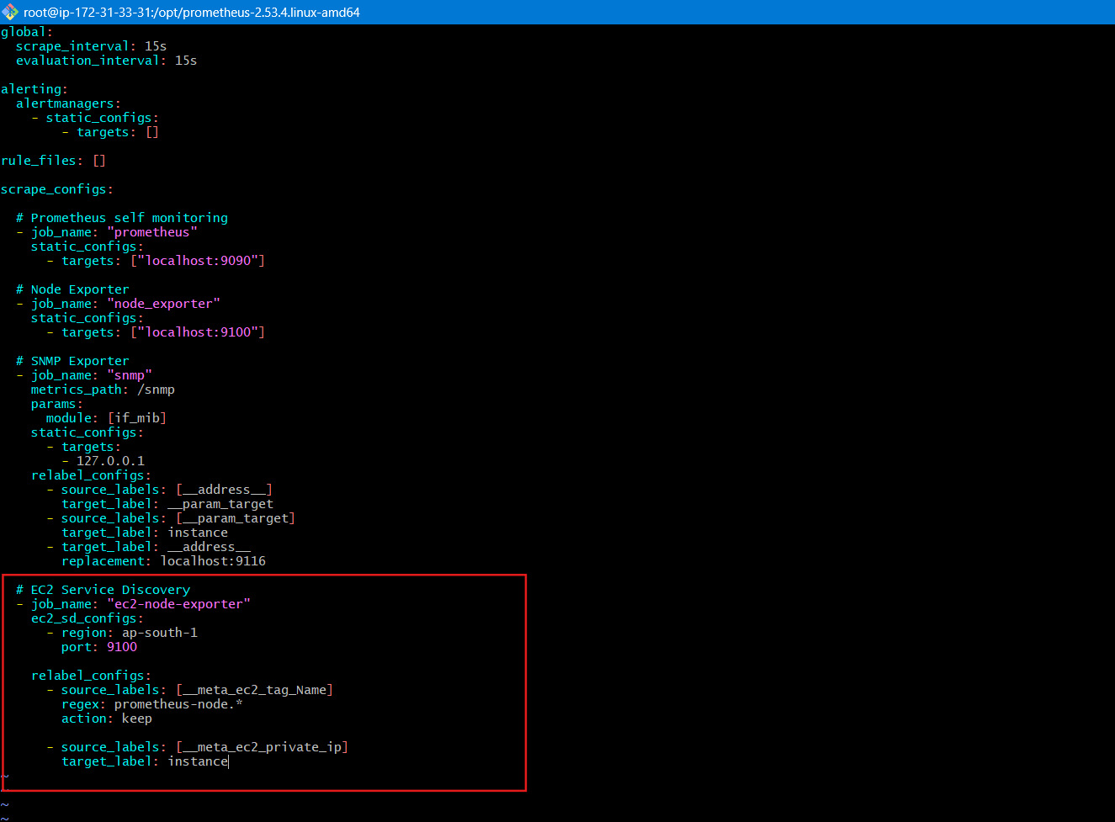
3️⃣ Restart Prometheus
If running via systemd:
sudo systemctl restart prometheus
If running manually:
pkill prometheus
./prometheus --config.file=prometheus.yml

Explanation
Service Discovery automatically:
- Detects new EC2 instances
- Filters them using tags
- Adds them as scrape targets
- No need to manually edit prometheus.yml
Prometheus will periodically query AWS API and update targets.
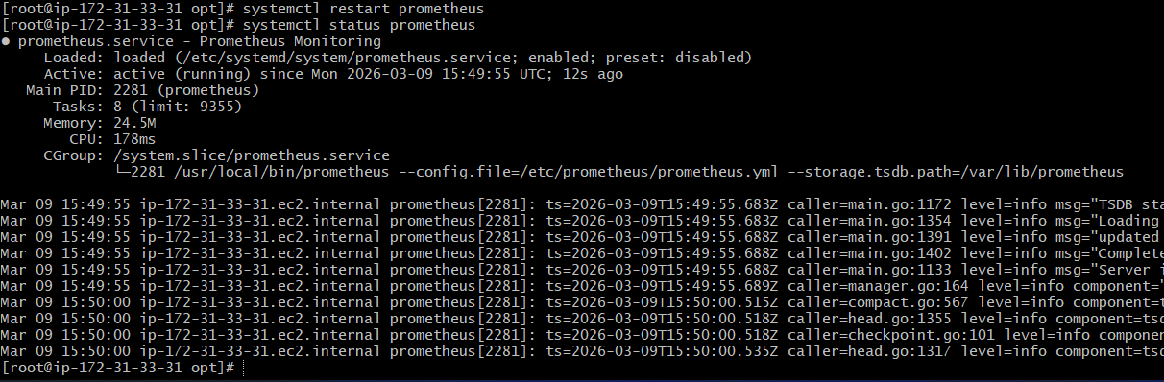

Validation

1️⃣ Launch a New EC2 Instance
- Open Amazon EC2 Console
- Click Launch Instance
- Choose Amazon Linux / Ubuntu (any Linux works)
- Configure Security Group to allow:
  - Port 9100 (Node Exporter)
  - Port 22 (SSH)
Add Tag
In the Tags section, add:
Key | Value
Name | prometheus-node-1
This tag is important because Prometheus EC2 service discovery will look for this tag.
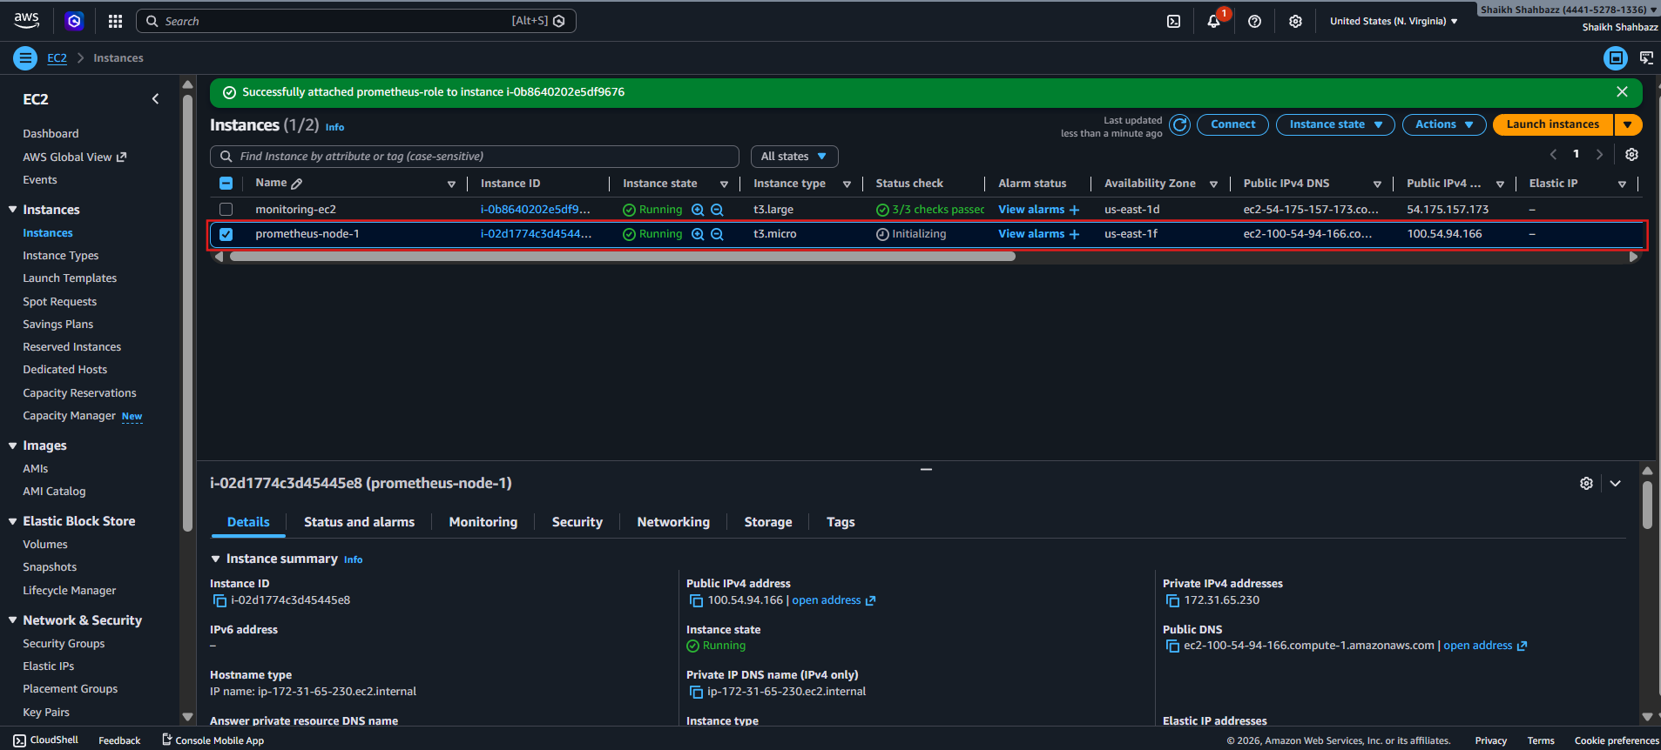
2️⃣ Install Node Exporter
SSH into the instance.
ssh ec2-user@INSTANCE_IP
Install Prometheus Node Exporter
cd /opt
wget https://github.com/prometheus/node_exporter/releases/download/v1.10.2/node_exporter-1.10.2.linux-amd64.tar.gz
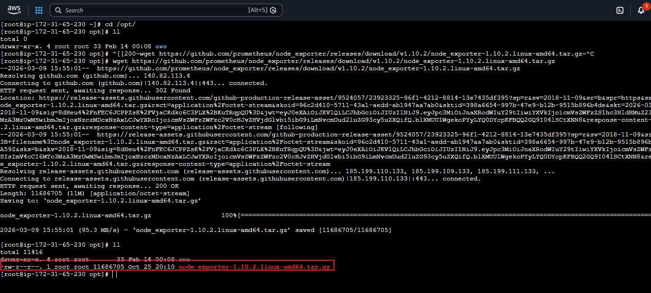
tar -xvf node_exporter-1.10.2.linux-amd64.tar.gz
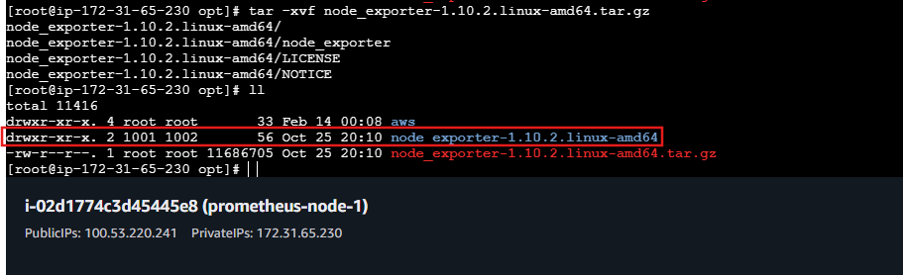
cd node_exporter-1.10.2.linux-amd64
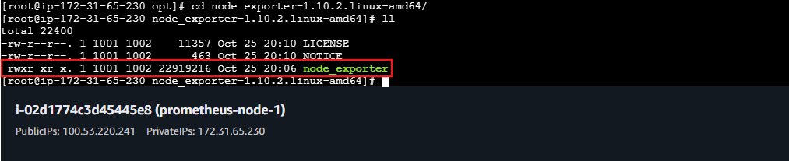
./node_exporter &
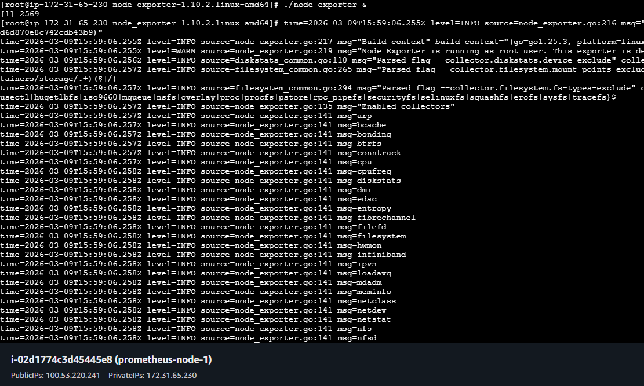
3️⃣ Verify Node Exporter is Running
Run:
curl localhost:9100/metrics
You should see metrics like:
node_cpu_seconds_total
node_memory_MemAvailable_bytes
node_disk_io_time_seconds_total
You can also test from your browser:
http://INSTANCE_IP:9100/metrics
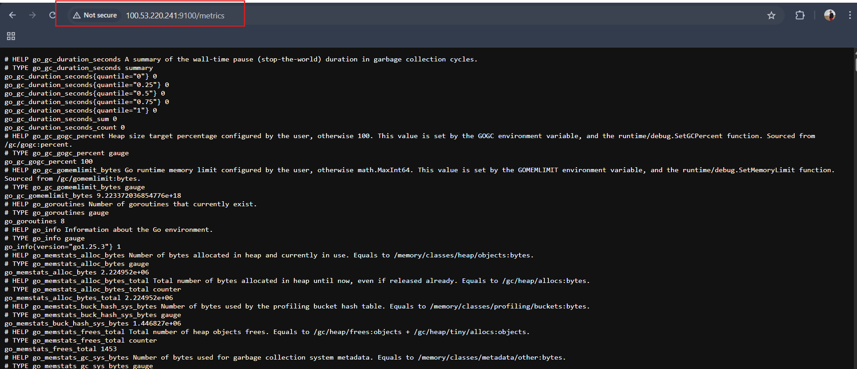
4️⃣ Check Prometheus UI
Open Prometheus web interface:
http://SERVER_IP:9090
Navigate to:
Status → Targets
Look for a target like:
Job | Status | Instance
ec2-node-exporter | UP | 10.x.x.x:9100
If everything works, it should show:
ec2-node-exporter UP
instance=10.x.x.x:9100
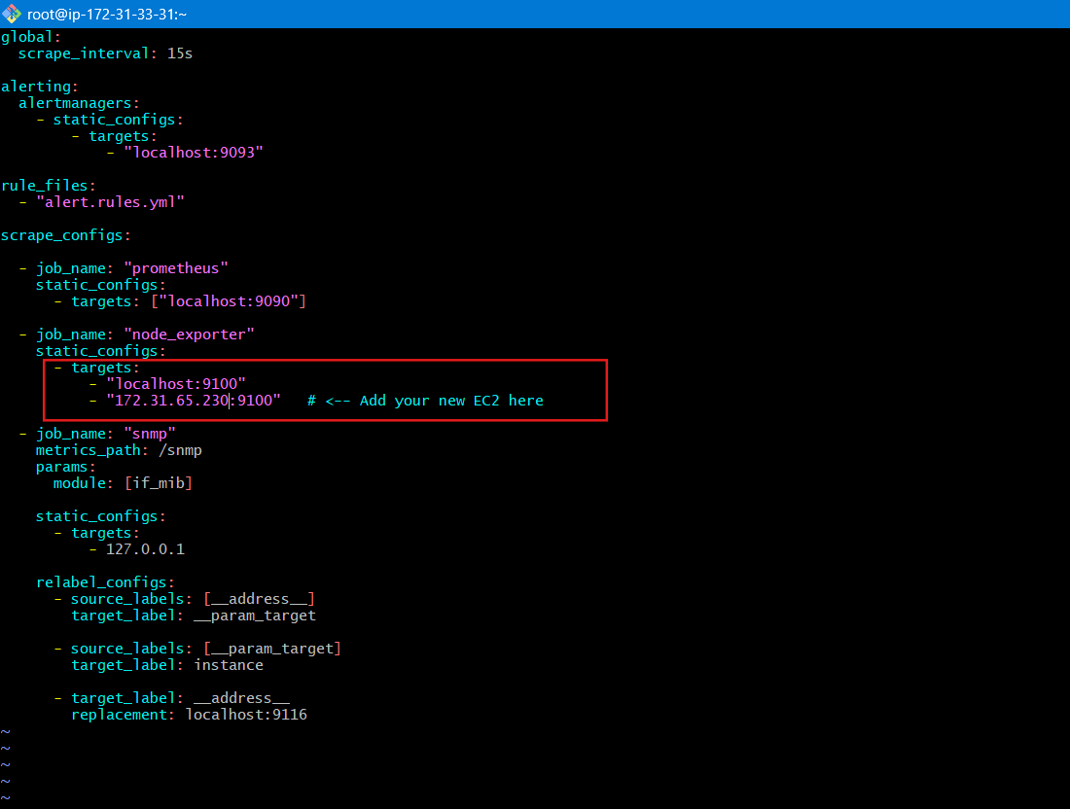

Restart Prometheus server
systemctl restart Prometheus
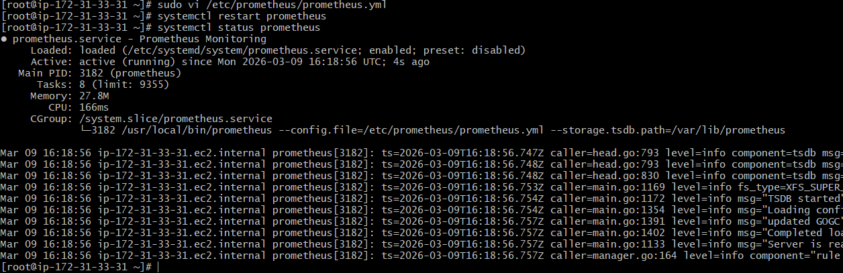

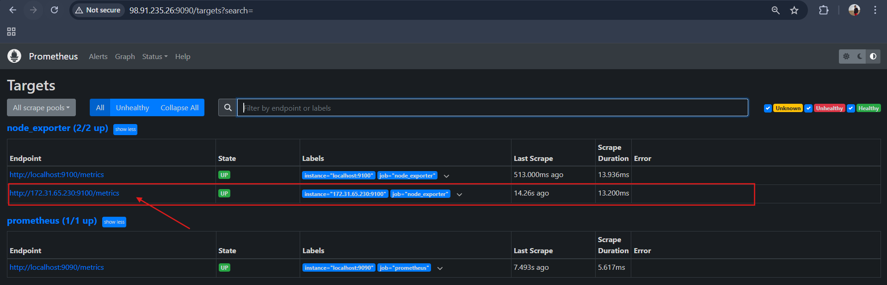

TASK 8: Create alerting rules for monitoring disk space.
1️⃣ Create Alert Rule File
sudo vi /opt/ prometheus-2.53.4.linux-amd64/disk-alerts.yml
Add this content:
groups:
- name: disk-alert
rules:
- alert: DiskSpaceLow
expr: (node_filesystem_avail_bytes / node_filesystem_size_bytes) * 100 < 20
for: 1m
labels:
severity: warning
annotations:
summary: "Disk space low"
description: "Less than 20% disk space left"
Save and exit.
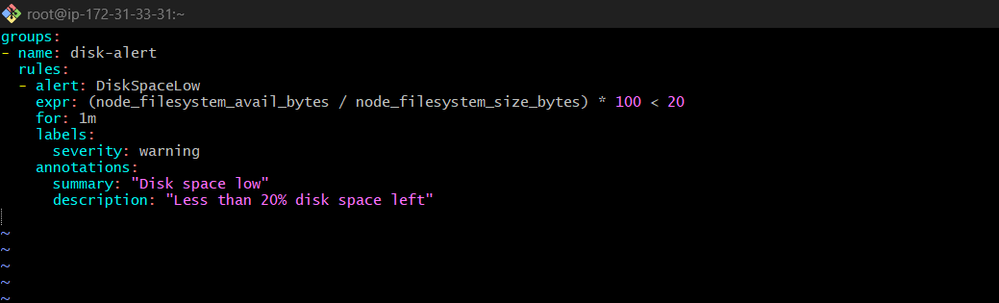
2️⃣ Add Rule File in prometheus.yml
Edit the Prometheus config:
sudo vi /opt/ prometheus-2.53.4.linux-amd64/prometheus.yml
Find the rule_files section and include the file:
rule_files:
- "disk-alerts.yml"
Example:
rule_files:
- "alert.rules.yml"
- "disk-alerts.yml"
⚠️ Make sure the file path is correct.
If Prometheus is running from /opt/ prometheus-2.53.4.linux-amd64, the above works.
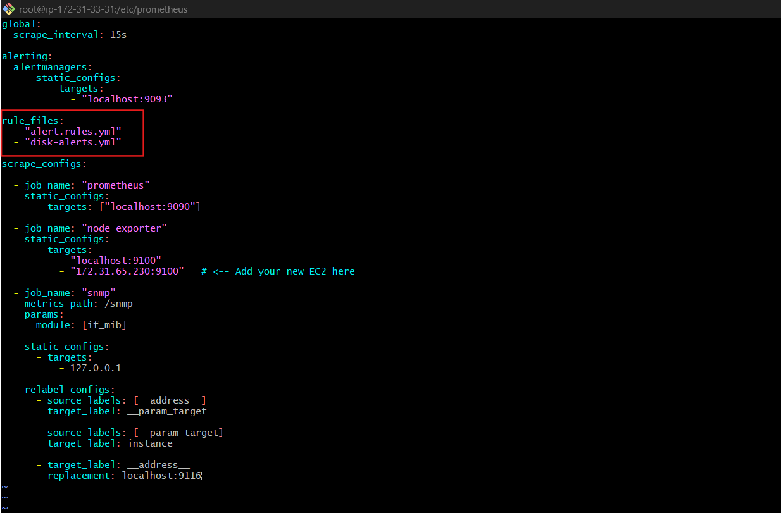
3️⃣ Restart Prometheus
sudo systemctl restart prometheus
Check status:
sudo systemctl status prometheus
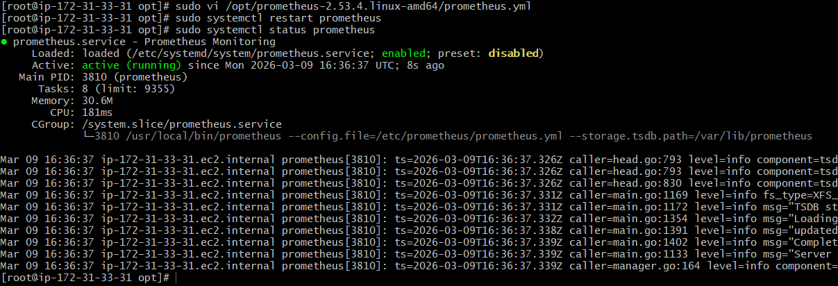
4️⃣ Validate Alert Rule
Open Prometheus UI:
http://<Prometheus-Server-IP>:9090/alerts
You should see DiskSpaceLow alert.
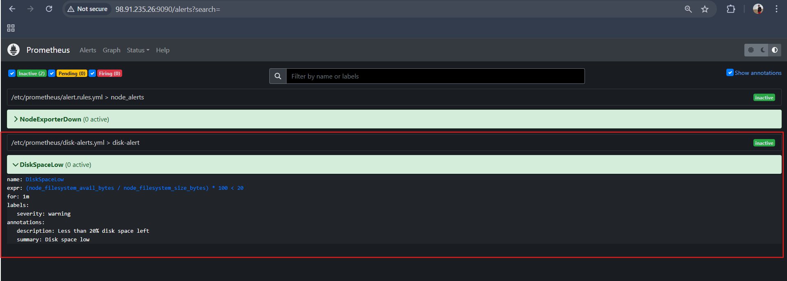
5️⃣ Trigger Alert Manually
Fill disk space to simulate low disk:
dd if=/dev/zero of=testfile bs=1M count=5000
This creates a 5GB file.
After 1 minute, the alert should trigger because:
Available disk space < 20%
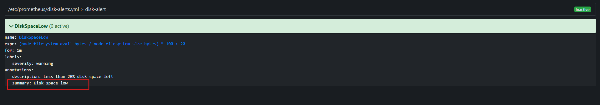
Go to Prometheus → Graph and run:
(node_filesystem_avail_bytes / node_filesystem_size_bytes) * 100
Example output:
68
55
42
Alert fires only when value < 20.

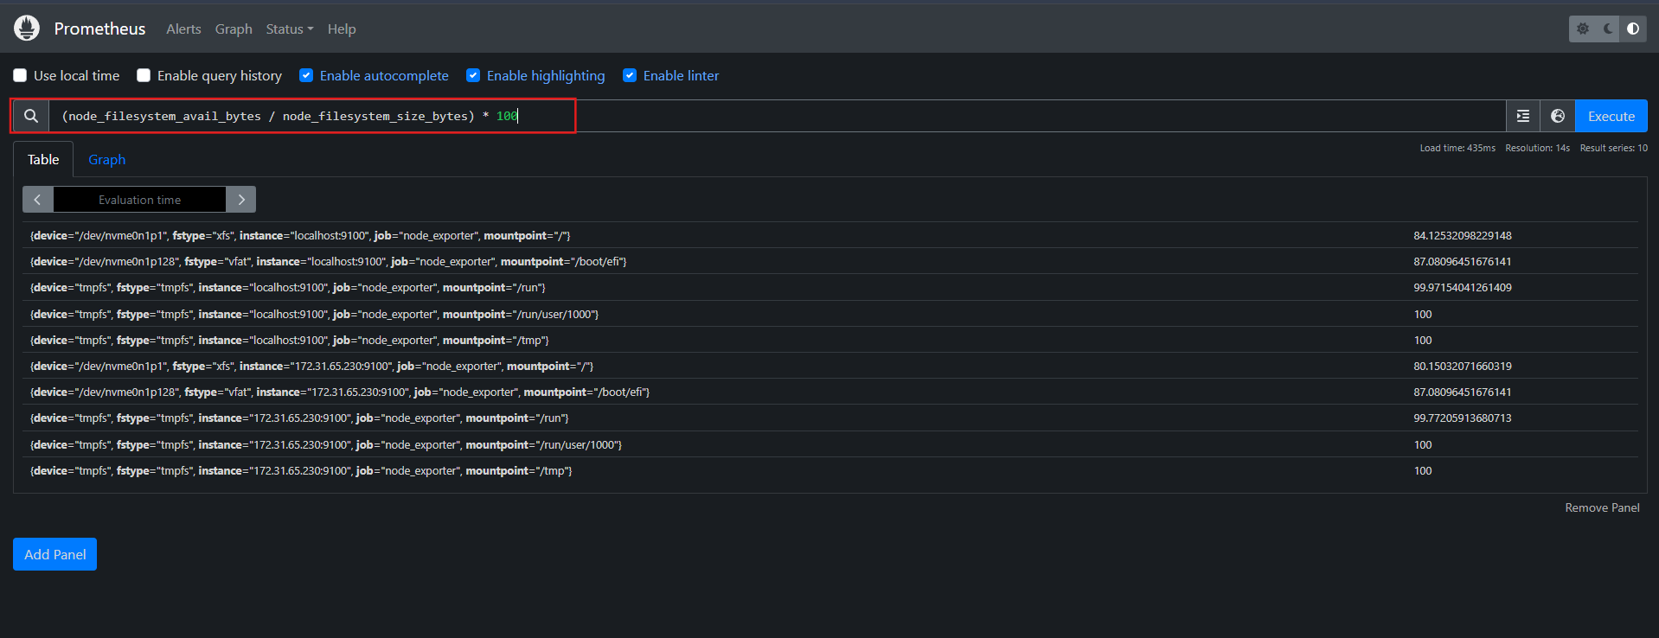

TASK 9: Create a custom Grafana dashboard using Prometheus metrics for specific insights.
1️⃣ Open Grafana
Open Grafana in your browser:
http://<Grafana-Server-IP>:3000
Login (default if not changed):
Username: admin
Password: grafana
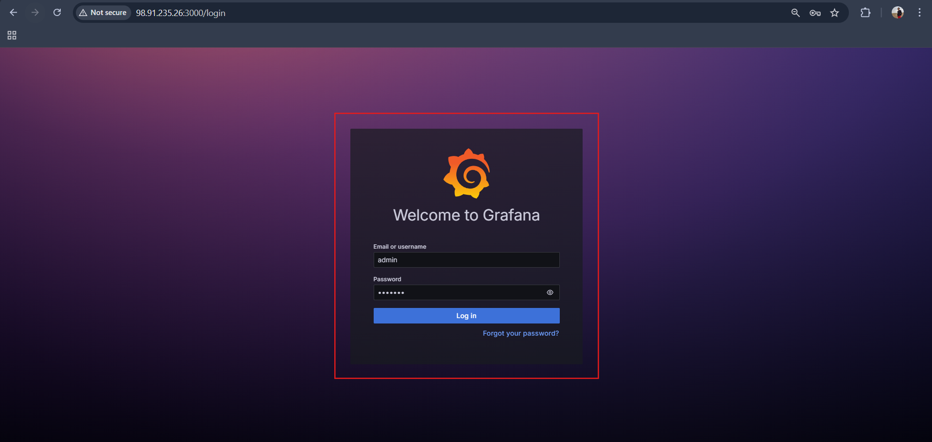
2️⃣ Create Dashboard
Left sidebar → + Create → Dashboard
Click:
Add Visualization
Select your Prometheus data source.
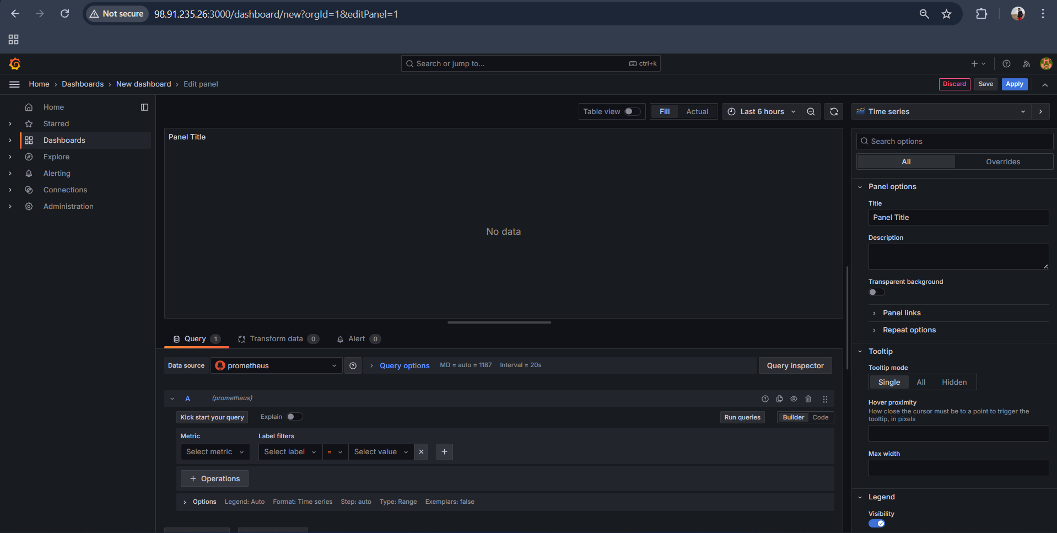
3️⃣ Panel 1 — CPU Usage
In Query section paste:
100 - (avg by(instance)(irate(node_cpu_seconds_total{mode="idle"}[5m])) * 100)
Settings:
Option | Value
Visualization | Time series
Title | CPU Usage %
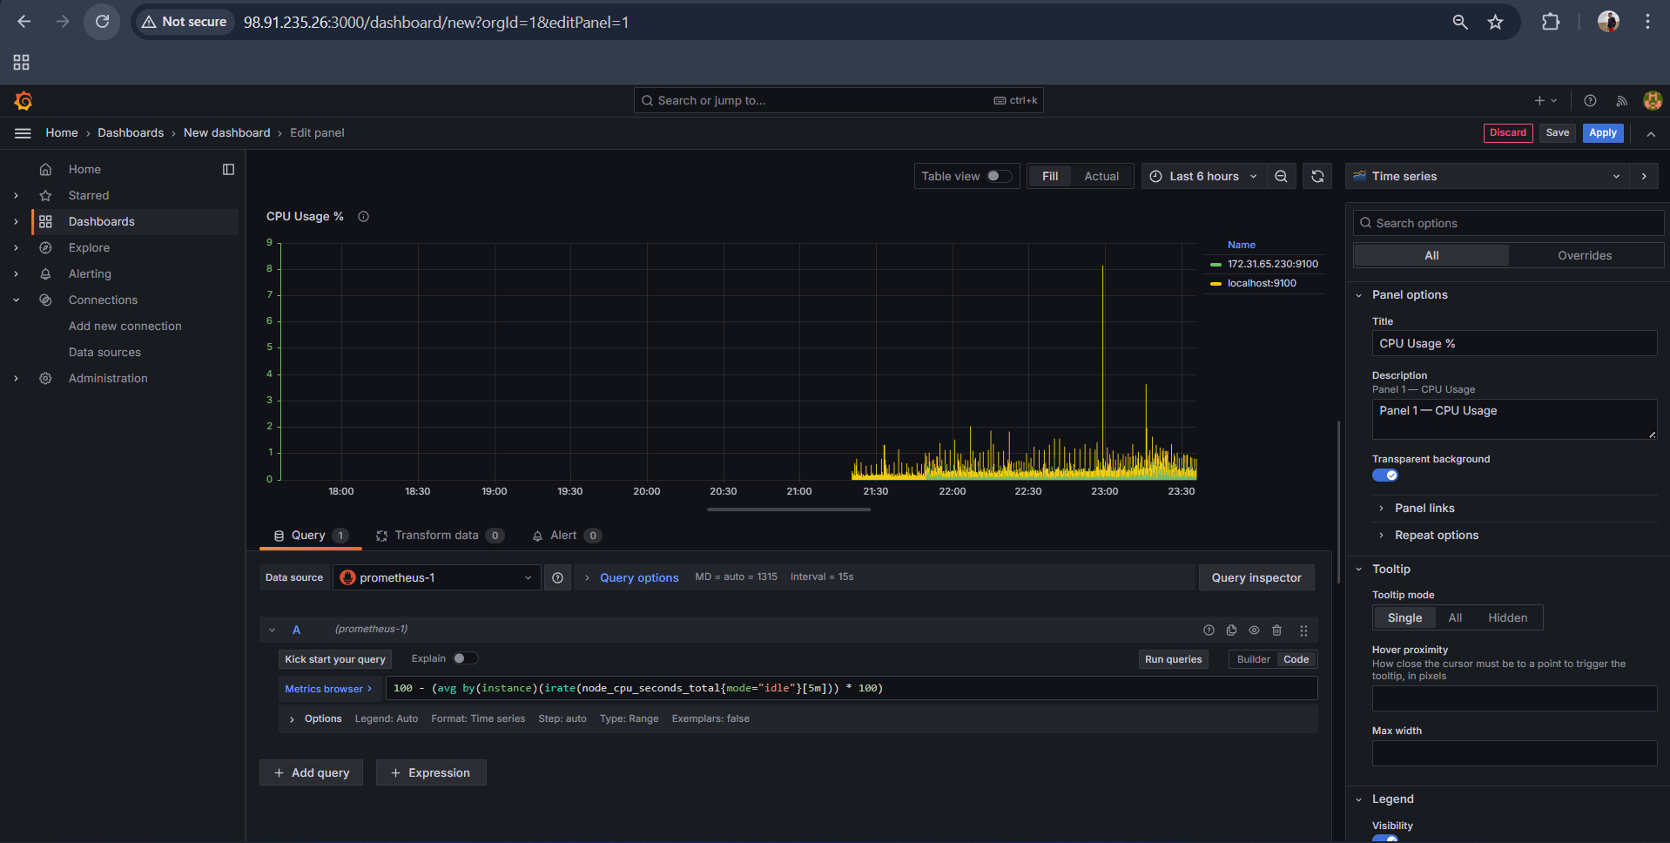
Click Apply.
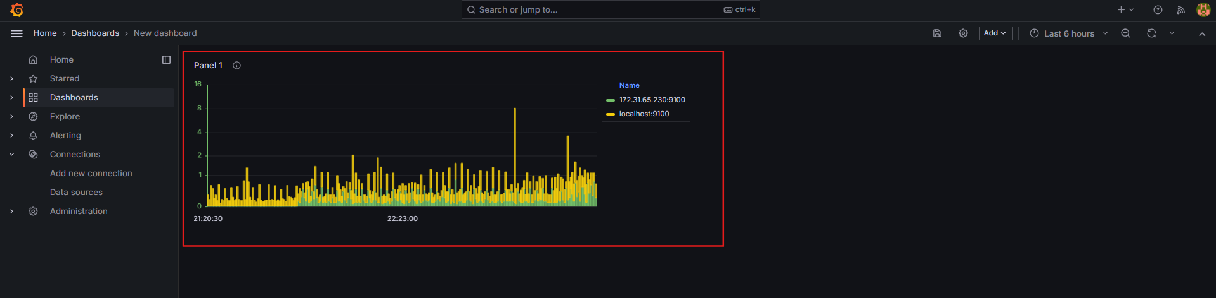

4️⃣ Panel 2 — Uptime
Click Add Visualization again.
Query:
(node_time_seconds - node_boot_time_seconds) / 3600
Settings:
Option | Value
Visualization | Stat
Title | System Uptime (Hours)
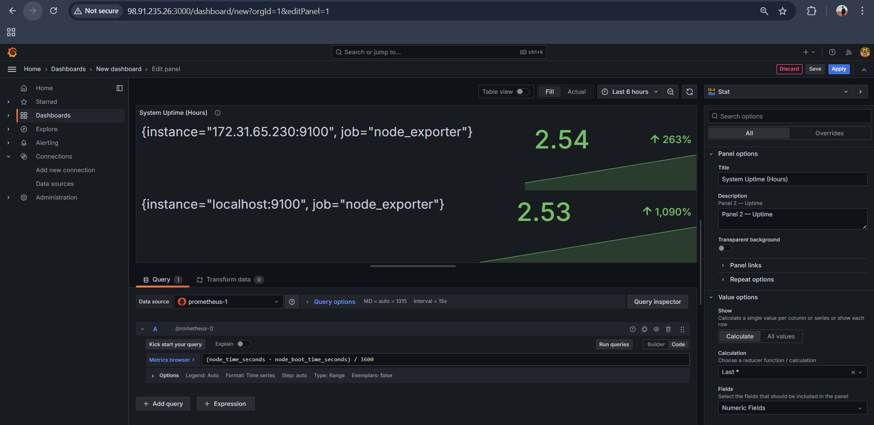
Click Apply.
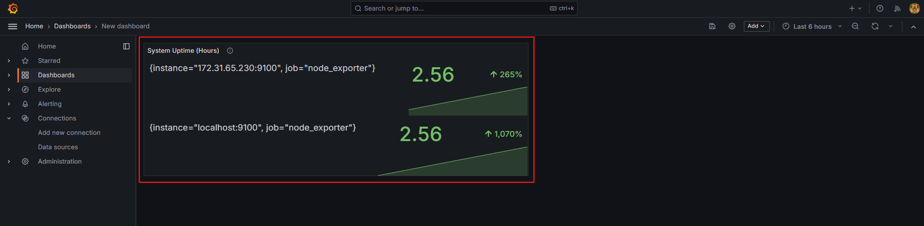
5️⃣ Panel 3 — Memory Usage
Add another visualization.
Query:
(node_memory_MemTotal_bytes - node_memory_MemAvailable_bytes) / 1024 / 1024
Settings:
Option | Value
Visualization | Gauge
Title | Memory Usage (MB)
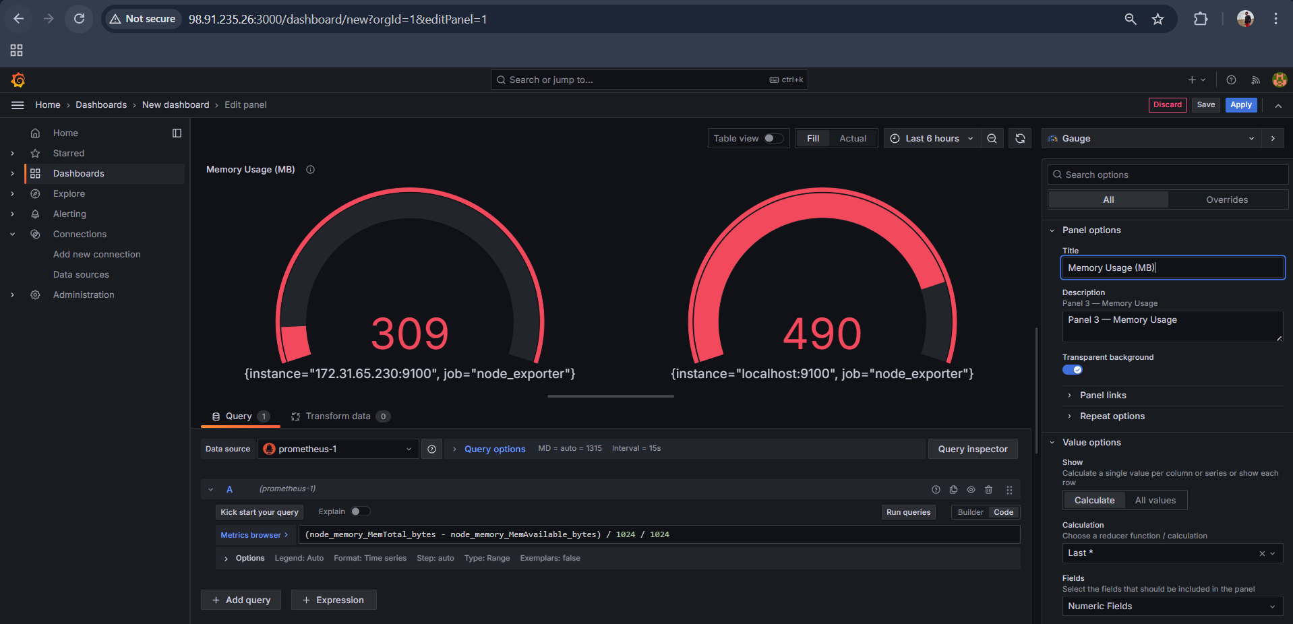
Click Apply.
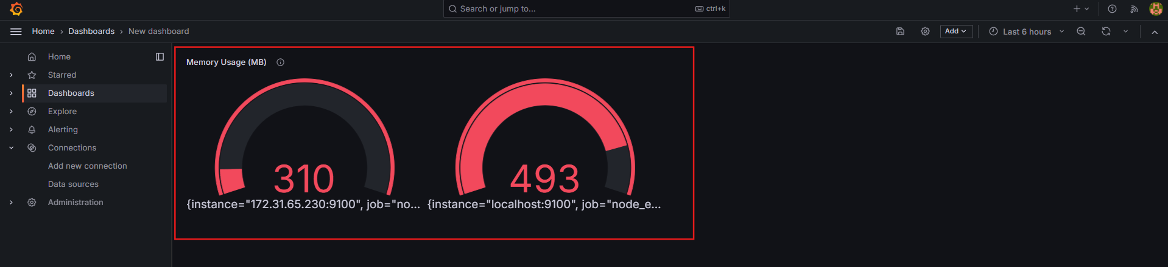
6️⃣ Panel 4 — Disk Usage
Add another panel.
Query:
(node_filesystem_size_bytes - node_filesystem_avail_bytes) / 1024 / 1024 / 1024
Settings:
Option | Value
Visualization | Gauge
Title | Disk Usage (GB)
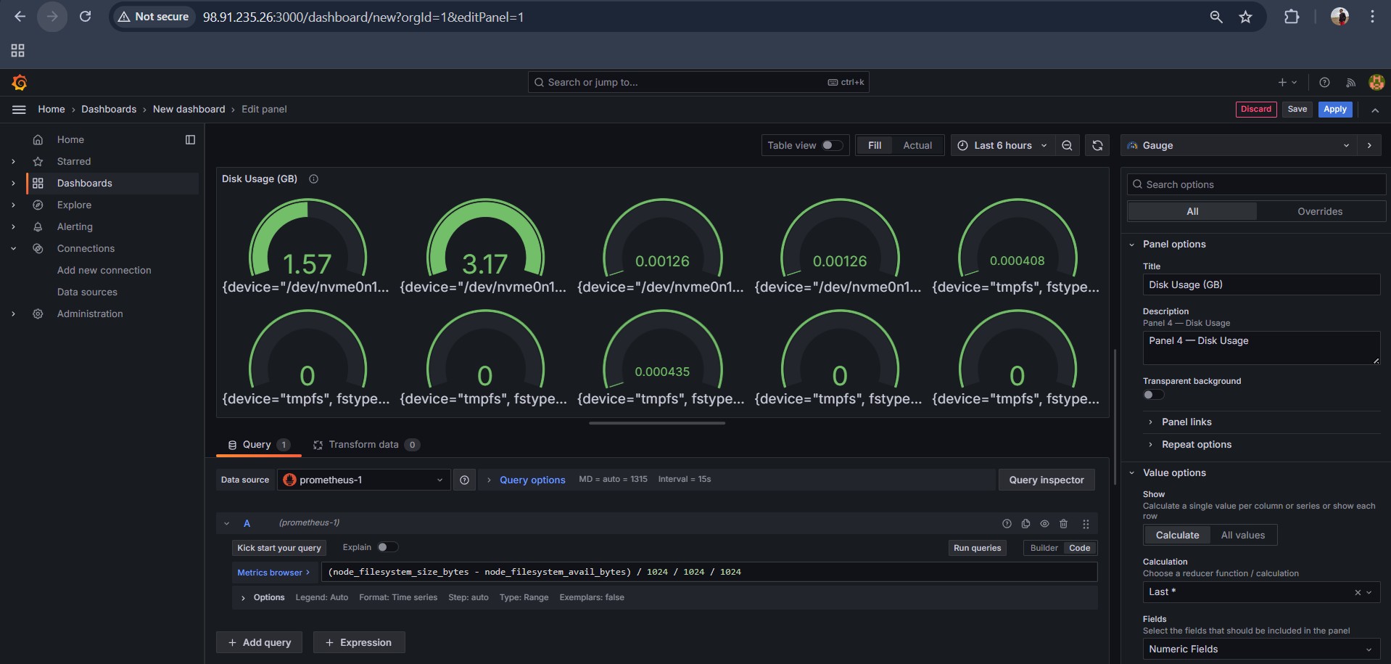
Click Apply.
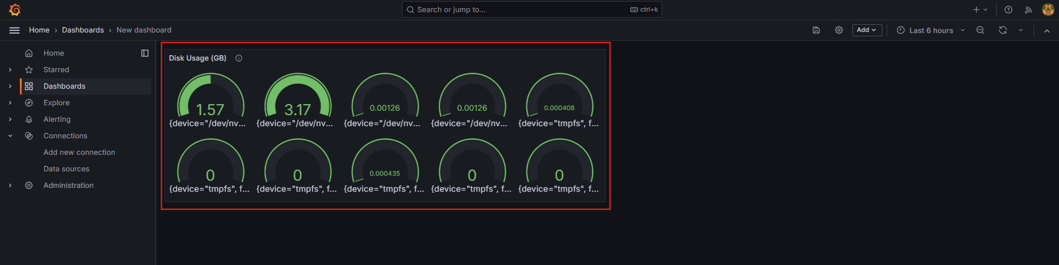
7️⃣ Save Dashboard
Click Save Dashboard (top right).
Name it:
Node Exporter Monitoring Dashboard
Click Save.
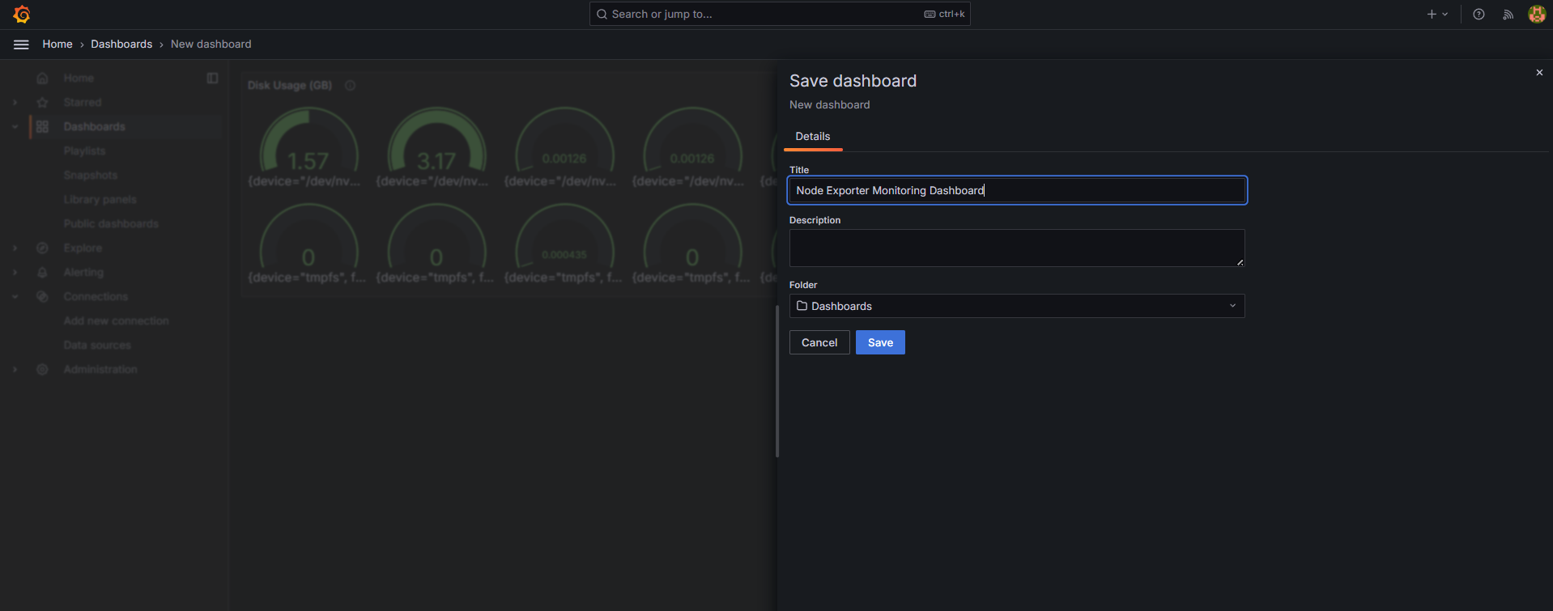
🔎 Validation
Your dashboard should now display real-time metrics:
Panel | Metric
CPU Usage | CPU utilization
Uptime | Server uptime
Memory | Memory usage
Disk | Disk usage
Metrics update every few seconds because Prometheus scrape interval is 15s.
